Assigned: Wednesday 4/11 DUE ON Wednesday 4/18, MUST SHOW WORK FOR CREDIT

UNIT 3: MODELING AND ANALYZING QUADRATIC FUNCTIONS Name ________________________________
Question |  | Answer
Interpret the Structure of Expressions
1. Consider the expression $3n^{2}+n+2.$

a. What is the coefficient of n?

b. What terms are being added in the expression?

2. Factor the expression $16a^{2}– 81$.

3. Factor x² + 5x + 4.

4. Factor the expression $12x^{2}+14x- 6$.

5. Which expression is equivalent to $121x^{2} – 64y^{2}$? |  | 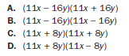
6. What is a common factor for the expression 24x² + 16x + 144?
A. 16
B. 8x
C. 3x² + 2x + 18
D. 8(x – 2)(3x2 + 9)

7. Which of these shows the complete factorization of 6x²y² – 9xy – 42?
A. 3(2xy² – 7)(xy² + 2)
- B. (3xy + 6)(2xy – 7)
- C. 3(2xy – 7)(xy + 2)
- D. (3xy² + 6)(2xy² – 7)

Write Expressions in Equivalent Forms to Solve Problems
8. Find the zeros of x² – 7x + 12 = 0

9. Write $f(x) = 2x^{2} + 6x + 1$ in vertex form.
10. The function $h(t) = –t^{2} + 8t + 2$ represents the height, in feet, of a stream of water being squirted out of a fountain after t seconds. What is the maximum height of the water?

11. What are the zeros of the function represented by the quadratic expression${ x}^{2}+6x-27$?

12. What are the zeros of the function represented by the quadratic expression ${2x}^{2}-5x-3$?

13. What are the zeros of the function represented by the quadratic expression $2x^{2} + x – 3$? |  | 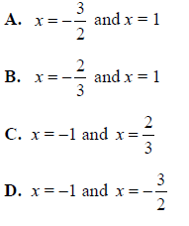
14. What is the vertex of the graph of
$$f(x) =x^{2} + 10x – 9?$$
A. (5, 66)
B. (5, –9)
C. (–5, –9)
D. (–5, –34)

15. The expression $–x^{2}+ 70x – 600$ represents a company’s profit for selling x items. For which number(s) of items sold is the company’s profit equal to $0?

A. 0 items
B. 35 items
C. 10 items and 60 items
D. 20 items and 30 items

Create Equations That Describe Numbers or Relationships
16. What is the value of r when S = 0 for the equation S = 2πr² + 2πrh for r?

17. The product of two consecutive positive integers is 132.

a. Write an equation to model the situation.

b. What are the two consecutive integers?

18. The formula for the volume of a cylinder is $V = πr^{2}h.$

a. Solve the formula for r.

b. If the volume of a cylinder is 200$π$ cubic inches and the height of the cylinder is 8 inches, what is the radius of the cylinder?

19. Graph the function represented by the equation $y = {3x}^{2} – 6x – 9$. |  | 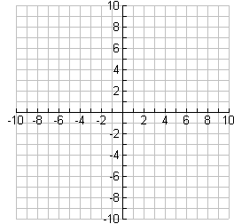
20. A garden measuring 8 feet by 12 feet will have a walkway around it. The walkway has a uniform width, and the area covered by the garden and the walkway is 192 square feet. What is the width of the walkway?

A. 2 feet
B. 3.5 feet
C. 4 feet
D. 6 feet

21. The formula for the area of a circle is $A = πr^{2}.$ Which equation shows the formula in terms of r? |  | 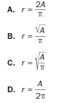
Solve Equations and Inequalities in One Variable
22. Solve the equation$x^{2} – 10x + 25 = 0$ by factoring.

23. Solve the equation $x^{2} – 100 = 0$ by using square roots.

24. Solve the equation 4x² – 7x + 3 = 0 using the quadratic formula.

25. What are the solutions to the equation
$2x^{2} – 2x – 12 = 0$?

A. x = –4, x = 3
B. x = –3, x = 4
C. x = –2, x = 3
D. x = –6, x = 2

26. What are the solutions to the equation  $6x^{2} – x – 40 = 0$? |  | 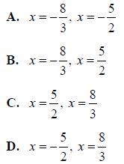
27. What are the solutions to the equation $x^{2} – 5x = 14$?

A. x = –7, x = –2
B. x = –14, x = –1
C. x = –2, x = 7
D. x = –1, x = 14

28. An object is thrown in the air with an initial velocity of 5 m/s from a height of 9 m. The equation $h(t) = –4.9t^{2} + 5t + 9$ models the height of the object in meters after t seconds. How many seconds does it take for the object to hit the ground?

A. 0.94 seconds
B. 1.77 seconds
C. 1.96 seconds
D. 9.0 seconds

BUILD A FUNCTION THAT MODELS A RELATIONSHIP BETWEEN TWO QUANTITIES
29. Annie is framing a photo with a length of 6 inches and a width of 4 inches. The distance from the edge of the photo to the edge of the frame is x inches. The combined area of the photo and frame is 63 square inches.  a. Write a quadratic function to find the distance from the edge of the photo to the edge of the frame.  b. How wide are the photo and frame together? | 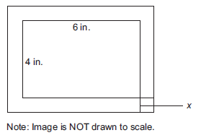
30. A scuba diving company currently charges $100 per dive. On average, there are 30 customers per day. The company performed a study and learned that for every $20 price increase, the average number of customers per day would be reduced by 2.

a. The total revenue from the dives is the price per dive multiplied by the number of customers. What is the revenue after 4 price increases?

b. Write a quadratic equation to represent x price increases.
c. What price would give the greatest revenue?
31. Consider the sequence 2, 6, 12, 20, 30, …

a. What explicit expression can be used to find the next term in the sequence?

b. What is the tenth term of the sequence?

32. What explicit expression can be used to find the next term in this sequence?
2, 8, 18, 32, 50, ...
A. 2n
B. 2n + 6
C. 2n²
D. 2n² + 1

33. The function $s(t) = vt + h – 0.5at^{2}$represents the height of an object, s, from the ground after time, t, when the object is thrown with an initial velocity of v, at an initial height of h, and where a is the acceleration due to gravity (32 feet per second squared). A baseball player hits a baseball 4 feet above the ground with an initial velocity of 80 feet per second. About how long will it take the baseball to hit the ground?

A. 2 seconds
B. 3 seconds
C. 4 seconds
D. 5 seconds

34. A café’s annual income depends on x, the number of customers. The function  $I( x)=4x^{2}-20x$ describes the café’s total annual income. The function $C( x)= 2x^{2} +5$  describes the total amount the café spends in a year. The café’s annual profit, P(x), is the difference between the annual income and the amount spent in a year. Which function describes P(x)? | A. $P(x)= 2x^{2} -20x-5$  B. $P(x)= 4x^{3} -20x^{2}$  C. $P(x)=6x^{2} -20x+5$  D. $P(x)=8x^{4}-40x^{3}-20x^{2} -100x$
Build New Functions from Existing Functions
35. Compare the graphs of the following functions to f(x).

a. $\frac{1}{2}f(x)$

b. f(x) – 5

c. f(x – 2) + 1

36. Is $f(x) = 2x^{3}+ 6x$ even, odd, or neither? Explain how you know.

37. How does the graph of f(x) compare to the graph of $f(\frac{1}{2}x)$?

38. Which statement BEST describes the graph of f(x + 6)?

A. The graph of f(x) is shifted up 6 units.
B. The graph of f(x) is shifted left 6 units.
C. The graph of f(x) is shifted right 6 units.
D. The graph of f(x) is shifted down 6 units.
39. Which of these is an even function?
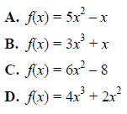

40. Which statement BEST describes how the graph of $g(x) = –3x^{2}$ compares to the graph of $f(x) = x^{2}$?

A. The graph of g(x) is a vertical stretch of f(x) by a factor of 3.
B. The graph of g(x) is a reflection of f(x) across the x-axis.
C. The graph of g(x) is a vertical shrink of f(x) by a factor of $\frac{1}{3}$
and a reflection across the x-axis.
D. The graph of g(x) is a vertical stretch of f(x) by a factor of 3 and a reflection across the x-axis.
Interpret Functions That Arise in Applications in Terms of the Context
41. A ball is thrown into the air from a height of 4 feet at time t = 0. The function that models this situation is
h(t) = $–16t^{2} + 63t + 4,$ where t is measured in seconds and h is the height in feet.

a. What is the height of the ball after 2 seconds?

b. When will the ball reach a height of 50 feet?

c. What is the maximum height of the ball?

d. When will the ball hit the ground?

e. What domain makes sense for the function?

42. This table shows a company’s profit, p, in thousands of dollars over time, t, in months.

Time, t, (months) | Profit, p (thousands of dollars)
3 | 18
7 | 66
10 | 123
15 | 258
24 | 627

a. Describe the average rate of change in terms of the given context.

b. What is the average rate of change of the profit between 3 and 7 months?

c. What is the average rate of change of the profit between 3 and 24 months?

43. A flying disk is thrown into the air from a height of 25 feet at time t = 0. The function that models this situation is $h(t) = –16t^{2} + 75t + 25$, where t is measured in seconds and h is the height in feet. What values of t best describe the times when the disk is flying in the air?

A. 0 < t < 5
B. 0 < t < 25
C. all real numbers
D. all positive integers

44. Use this table to answer the question.  $$x$$ $$f(x)$$  -2 15  -1 9  0 5  1 3  2 3 | What is the average rate of change of f(x) over the interval –2 ≤ f(x) ≤ 0?  A. –10  B. –5  C. 5  D. 10
45. What is the end behavior of the graph of  $f(x) = –0.25x^{2} – 2x +$1? | A. As x increases, f(x) increases.  As x decreases, f(x) decreases.  B. As x increases, f(x) decreases.  As x decreases, f(x) decreases.  C. As x increases, f(x) increases.  As x decreases, f(x) increases.  D. As x increases, f(x) decreases.  As x decreases, f(x) increases.
ANALYZE FUNCTIONS USING DIFFERENT REPRESENTATIONS
46. Graph the function $f(x) = x^{2}– 5x – 24$.
47. This graph shows a function f(x). Compare the graph of f(x) to the graph of the function given by the equation  $g(x) = 4x^{2} + 6x – 18$. Which function has the lesser minimum value? How do you know? 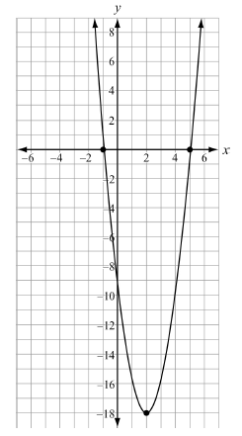 | 48. Use the graph below to answer the question.  Which function is shown in the graph?  $$A. f(x) =x^{2} – 3x – 10$$  $$B. f(x) =x^{2} + 3x – 10$$  $$C. f\left(x\right)=x^{2} + x – 12$$  $$D.. f(x) = x^{2} – 5x – 8$$  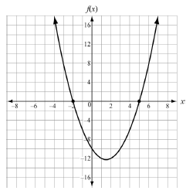
49. The function $f(t) = –16x^{2} + 64t + 5$ models the height of a ball that was hit into the air,  where t is measured in seconds and h is the height in feet. This table represents the height, g(t), of a second ball that was thrown into the air.  Time, t (in seconds) Height, g(t) (in feet)  0 4  1 36  2 36  3 4 | Which statement BEST compares the length of time each ball is in the air?  A. The ball represented by f(t) is in the air for about 5 seconds, and the ball represented by  g(t) is in the air for about 3 seconds.  B. The ball represented by f(t) is in the air for about 3 seconds, and the ball represented by  g(t) is in the air for about 5 seconds.  C. The ball represented by f(t) is in the air for about 3 seconds, and the ball represented by  g(t) is in the air for about 4 seconds.  D. The ball represented by f(t) is in the air for about 4 seconds, and the ball represented by  g(t) is in the air for about 3 seconds.

