Assigned: Thursday 4/19 DUE ON WEDNESDAY 4/25, MUST SHOW WORK FOR CREDIT
UNIT 4: MODELING AND ANALYZING EXPONENTIAL FUNCTIONS Name ___________________________________
Question |  | Answer
Create Equations That Describe Numbers or Relationships
1. An amount of $1,000 is deposited into a bank account that pays 4% annual interest. If there are no other withdrawals or deposits, what will be the balance of the account after 3 years?

2. The city of Arachna has a spider population that has been doubling every year. If there are about 100,000 spiders this year, how many will there be 4 years from now?

3. A certain population of bacteria has an average growth rate of 0.02 bacteria per hour. The formula for the growth of the bacteria’s population is A ₀= P(2.71828)^{0.02t} , where P₀ is the original population, and t is the time in hours. If you begin with 200 bacteria, about how many bacteria will there be after 100 hours? | A. 7  B. 272  C. 1,478  D. 20,000
4. Pete withdraws half his savings every week. If he started with $400, what rule be written for how much Pete has left each week?

5. Consider the number of sit-ups Clara does each week as listed in the sequence 3, 6, 12, 24, 48, 96, 192. | a) Is this an arithmetic or geometric sequence?  b) What is the explicit formula?  c) What is the recursive rule?
6. A scientist collects data on a colony of microbes. She notes these numbers:  Day a_{n}  1 800  2 400  3 200  4 100  5 50 | What function can she use to model the population size?
6. The temperature of a large tub of water that is currently at 100° decreases by about 10% each hour.

Part A: Write an explicit function in the form f(n) = a · b^{n} to represent the temperature, f(n), of the tub of water in n hours.

Part B: A recursive function in the form f(n) = r(f(n – 1)), where f(1) = 100, can be written for the temperature problem. What recursive function represents the temperature, f(n), of the tub in hour n?

7.
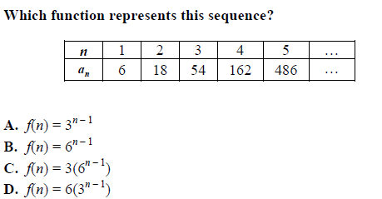

8. The points (0, 1), (1, 5), (2, 25), (3, 125) are on the graph of a function. Which equation represents that function?

A. ${f(x) = 2}^{x}$
B. ${f(x) = 3}^{x}$
C. $f(x) = 4^{x}$
D. ${f(x) = 5}^{x}$

Build New Functions from Existing Functions
9. If $f\left(x\right)=2^{x}$, how will g(x) = f(x) + 2 and h(x) = f(x) – 3 compare? | 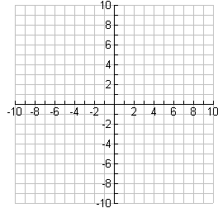
10. If $f\left(x\right)=2^{x}$, how will g(x) = 3f(x) , h(x) = $\frac{1}{3}$ f(x), and $m\left(x\right)=-f(x)$ compare?

11. For the function $f\left(x\right)= 3^{x},$ find the function that represents a 5 unit translation up of the function.

12. Given the function f(x) $=2^{(x-2)} ,$ complete each of the following:

a. Compare f(x) to 3f(x).

b. Compare f(x) to f(3x).

c. Draw the graph of -f(x).

d. Which has the fastest growth rate: f(x), 3f(x), or -f(x)?

13. Which function shows the function f(x) = 3x being translated 5 units to the left? | A. f(x) = 3^{x} – 5  B. f(x) = 3^{(x + 5)}  C. f(x) = 3^{(x – 5)}  D. f(x) = 3^{x} + 5
14. Which function shows the function f(x) = 3x being translated 5 units down? | A. f(x) = 3^{x} – 5  B. f(x) = 3^{(x + 5)}  C. f(x) = 3^{(x – 5)}  D. f(x) = 3^{x} + 5
Understand the Concept of a Function and Use Function Notation

15. Given f(x) = 2(3)^{x}, find f(7).

16. If g(6) = 2⁽⁶⁾ + 1, what is g(x)?

17. If f(–2) = 4^{(–2),} what is f(b)?

18. Graph $f\left(x\right)=4^{(x)}-5$.

19. A population of bacteria begins with 2 bacteria on the first day and triples every day. The number of bacteria after x days can be represented by the function P(x) = 2(3)x . | a. What is the common ratio of the function?  b. What is a₁ of the function?  c. Write a recursive formula for the bacteria growth.  d. What is the bacteria population after 10 days?
20. Consider the first six terms of the following sequence: 1, 3, 9, 27, 81, 243, . . .

a. What is a₁? What is a₃?

b. What is the reasonable domain of the function?

c. If the sequence defines a function, what is the range?

d. What is the common ratio of the function?

21. The function f(n) = –(1 – 4^{n}) represents a sequence. Create a table showing the first five terms in the sequence. Identify the domain and range of the function.

22. Consider this pattern. Which function represents the sequence that represents the pattern?

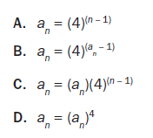
23. Which function is modeled in this table?  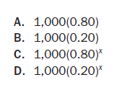 | 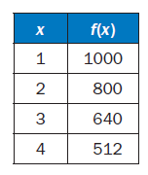
24. Which explicit formula describes the pattern in this table?  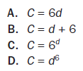 | 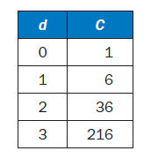
25.
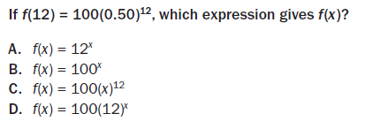
Interpret Functions That Arise in Applications in Terms of the Context
26. Find the following features of $f\left(x\right)=2^{x}.$  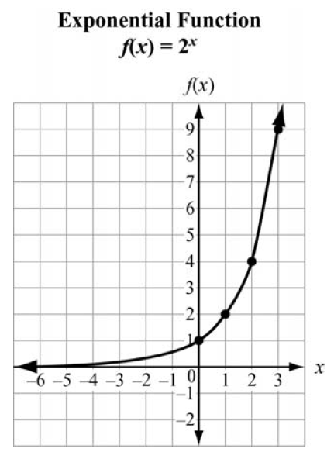 | Domain:  Range:  x-intercept:  y-intercept:  Interval of Increase:  Interval of Decrease:  Maximum:  Minimum:  Rate of Change:  Asymptote:
27. The amount accumulated in a bank account over a time period t and based on an initial deposit of $200 is found using the formula $A(t) = {200(1.025)}^{t}, t≥ 0$. Time, t, is represented on the horizontal axis. The accumulated amount, A(t), is represented on the vertical axis.  a. What are the intercepts of the function?  b. What is the domain of the function?  c. Why are all the t values non-negative?  d. What is the range of the function? | 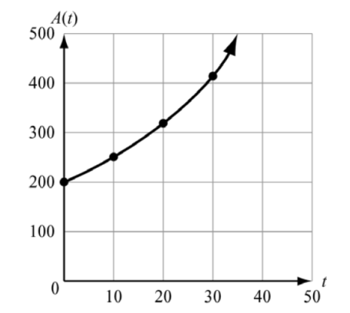
28. Consider two exponential functions, If $f\left(x\right)=3^{x}$and $f\left(x\right)={\left(\frac{1}{3}\right)}^{x}$. Compare the key features of the two functions.

f(x) | g(x)
Domain:  Range:  x-intercept:  y-intercept:  Interval of Increase:  Interval of Decrease:  Rate of Change:  Asymptote: | Domain:  Range:  x-intercept:  y-intercept:  Interval of Increase:  Interval of Decrease:  Rate of Change:  Asymptote:

29. A population of squirrels doubles every year. Initially, there were 5 squirrels. A biologist studying the squirrels created a function to model their population growth: P(t) = 5^{(2t),} where t is the time in years. The graph of the function is shown.  What is the range of the function?  A. any real number  B. any whole number greater than 0  C. any whole number greater than 5  D. any whole number greater than or equal to 5 | 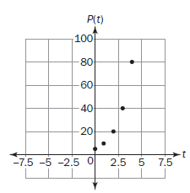
30. The function graphed on this coordinate grid shows f(x), the height of a dropped ball in feet after its xth bounce. On which bounce was the height of the ball 10 feet?  A. bounce 1  B. bounce 2  C. bounce 3  D. bounce 4 | 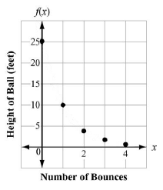
Analyze Functions Using Different Representations
31. Consider $f(x) = 2^{x}, g(x) = 5 · 2^{x}, and h(x) = {–2}^{x}$. Compare the rates of change, y-intercepts, and end behaviors of each graph.

 | $$f(x)$$ | $$g(x)$$ | $$h(x)$$
End Behavior: | As x increases, f(x) ________.  As x decreases, f(x) _________. | As x increases, f(x) ________.  As x decreases, f(x) _________. | As x increases, f(x) ________.  As x decreases, f(x) _________.
y-intercept
Rate of Change

32. Two quantities increase at exponential rates. This table shows the value of Quantity A, f(x), after x years.

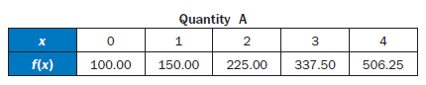
This function represents the value of Quantity B, g(x), after x years.
g(x) = 50(2)^{x}
Which quantity will be greater at the end of the fourth year and by how much?

33. Look at the graph. Which equation represents this graph?  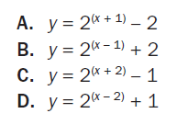 | 