Assigned: Monday 4/23 DUE ON FRIDAY 4/27, MUST SHOW WORK FOR CREDIT
UNIT 5: COMPARING AND CONTRASTING FUNCTIONS Name ________________________________________
Question | Answer
Construct and Compare Linear, Quadratic, and Exponential Models and Solve Problems
1. Given the table below, determine if the table represents an exponential or linear function. | 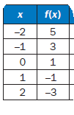
2. Given the graph to the right, compare the coordinates of points to determine if there is either linear or exponential growth. The points represent the profit/loss of a new company over its first 5 years, from 2008 to 2012. | 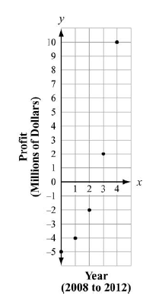
3. Suppose you start work and earn $30,000 per year. After one year, you are given two choices for getting a raise: a) 2% per year or b) $600 plus a flat $15-per-year raise for each successive year. Which option is better?

4. The swans on Elsworth Pond have been increasing in number each year. Felix has been keeping track, and so far he has counted 2, 4, 7, 17, and 33 swans each year for the past 5 years.  a. Make a scatter plot of the swan populations.  b. What type of model would be a better fit, linear or exponential? Explain your answer.  c. How many swans should Felix expect next year if the trend continues? Explain your answer. | 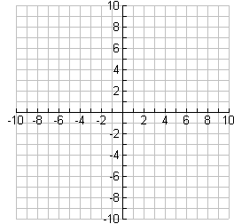
5. Given the sequence 7, 10, 13, 16, . . .

a. Does it appear to be linear or exponential?
b. Determine a function to describe the sequence.
c. What would the 20th term of the sequence be?

6. This table shows that the value of f(x) = 5x² + 4 is greater than the value of g(x) = 2^{x} over the interval [0, 8]. As x increases, will the value of f(x) always be greater than the value of g(x)? Explain how you know. | 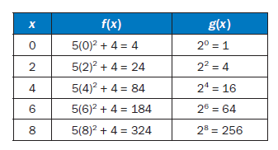
7. How does the growth rate of the function f(x) = 2x + 3 compare with
g(x) = 0.5x² – 3? Use a graph to explain your answer.

8. Which scatter plot BEST represents a model of linear growth?  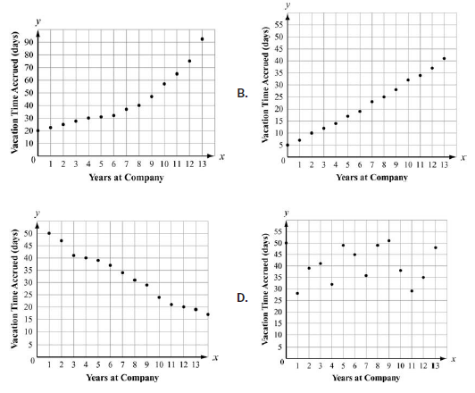 | 9. Which scatter plot BEST represents a model of exponential growth?  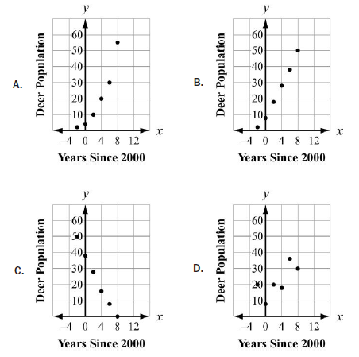
10. Which statement is true about the graphs of exponential functions? | A. The graphs of exponential functions never exceed the graphs of linear and quadratic functions.  B. The graphs of exponential functions always exceed the graphs of linear and quadratic functions.  C. The graphs of exponential functions eventually exceed the graphs of linear and quadratic functions.  D. The graphs of exponential functions eventually exceed the graphs of linear functions but not quadratic functions.
11. Which table represents an exponential function? | 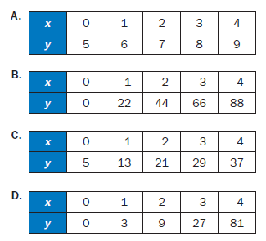
12. A table of values is shown for f(x) and g(x).  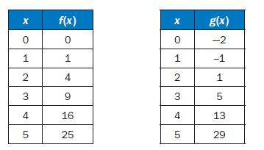 | Which statement compares the graphs of f(x) and g(x) over the interval [0, 5]?  A. The graph of f(x) always exceeds the graph of g(x) over the interval [0, 5].  B. The graph of g(x) always exceeds the graph of f(x) over the interval [0, 5].  C. The graph of g(x) exceeds the graph of f(x) over the interval [0, 4], the graphs intersect at a point between 4 and 5, and then the graph of f(x) exceeds the graph of g(x).  D. The graph of f(x) exceeds the graph of g(x) over the interval [0, 4], the graphs intersect at a point between 4 and 5, and then the graph of g(x) exceeds the graph of f(x).
12. Which statement BEST describes the comparison of the function values for f(x) and g(x)?  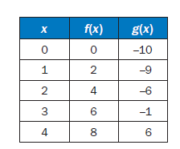 | A. The values of f(x) will always exceed the values of g(x).  B. The values of g(x) will always exceed the values of f(x).  C. The values of f(x) exceed the values of g(x) over the interval [0, 5].  D. The values of g(x) begin to exceed the values of f(x) within the interval [4, 5]
Interpret Expressions for Functions in Terms of the Situation They Model
13. Consider the lines f(x) = x, g(x) = 2x, h(x) = −x, and g(x) = x + 3. Make a table and graph. Compare.

 | $$f(x)$$ | $$g(x)$$ | $$h(x)$$
y-intercept
Rate of Change
Translations/Reflections

14. Consider the exponential curves f(x) = 2^{x}, g(x) = 2^{−x}, h(x) = 2^{2x}, and i(x) = 2^{x + 3}.

 | $$f(x)$$ | $$g(x)$$ | $$h(x)$$
y-intercept
Rate of Change
Translations/Reflections

15. Katherine has heard that you can estimate the outside temperature from the number of times a cricket chirps. It turns out that the warmer it is outside, the more a cricket will chirp. She has these three pieces of information:
- A cricket chirps 76 times a minute at 56° (76, 56).
- A cricket chirps 212 times per minute at 90° (212, 90).
- The relationship is linear.

Estimate the function.

18. Alice finds that her flower bulbs multiply each year. She started with just 24 tulip plants. After one year she had 72 plants. Two years later she had 120. Find a linear function to model the growth of Alice’s bulbs.
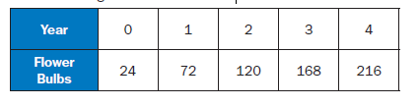

19. Suppose Alice discovers she counted wrong the second year and she actually had 216 tulip plants. She realizes the growth is not linear because the rate of change was not the same. She must use an exponential model for the growth of her tulip bulbs. Find the exponential function to model the growth.

20. If the parent function is f(x) = mx + b, what is the value of the parameter m for the line passing through the points (–2, 7) and (4, 3)?

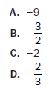

21. Consider this function for cell duplication. The cells duplicate every minute.
f(x) = 75(2)^{x}
Describe the parameters of this function.

Build New Functions from Existing Functions
22. Look at the graphs of the function f(x) = x² + 1 and g(x) = x – 1. | 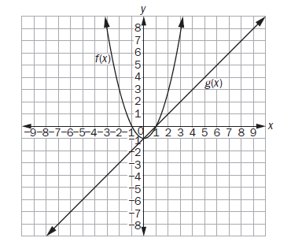
23. 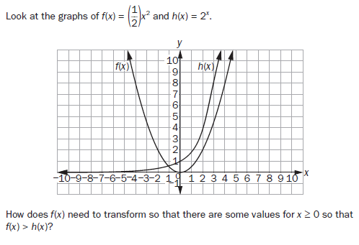

24. Look at the graph of the functions h(x) and p(x). Which transformations of h(x) and p(x) translate each function so both pass  through the point (0, 1)?  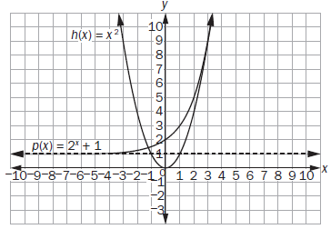 | 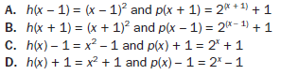
25.
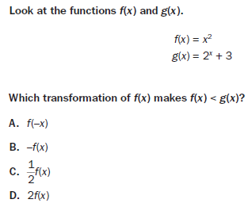

Understand the Concept of a Function and Use Function Notation
26. Look at the three functions and their graphs. Compare.

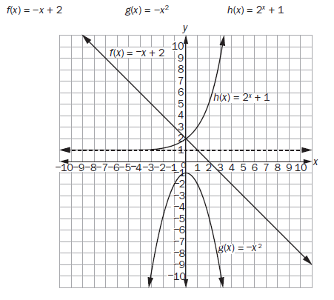
 | $$f(x)$$ | $$g(x)$$ | $$h(x)$$
Domain
Range
asymptote

27. Look at the two functions and their graphs. Compare.  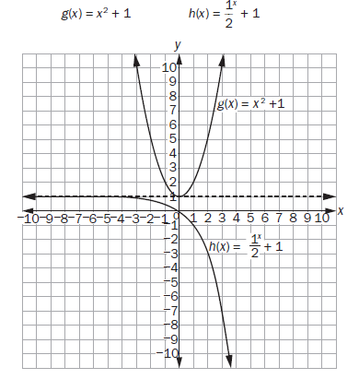 | $$f(x)$$ $$g(x)$$  Domain  Range  asymptote  Minimum
28. A manufacturer keeps track of her monthly costs by using a “cost function” that assigns a total cost for a given number of manufactured items, x. The function is C(x) = 5,000 + 1.3x.

a. What is the reasonable domain of the function?
b. What is the cost of 2,000 items?

29. As the input x increases by a factor of 3, the output g(x) doubles. What type of function fits this situation?

30. Which function is modeled in this table?  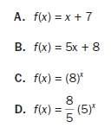 | 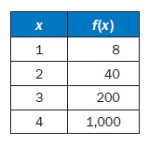
31. If f(12) = 4(12) – 20, which function gives f(x)?  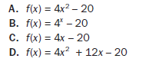 | 32. 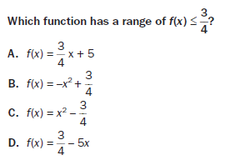
Interpret Functions That Arise in Applications in Terms of the Context
33. Roger is washing cars for people in his neighborhood. He bought cleaning supplies with his own money before he began washing cars. He charges a flat fee of $15 for each car washed. Roger’s total amount of profit, y, in dollars, for washing x cars can be modeled by the function y = 15x – 40.

a. What is the domain of this function?

b. What does the y-intercept of this function represent?

34. Miranda has an investment that earns 8% interest each year. She calculates that over the first 5 years, her $1,000 investment will earn an average of approximately $94 per year. At this rate, she thinks it will take more than 10 years to double her money. The graph shows the function modeling her investment, V(t) = 1,000(1.08)t, where t represents the time in years.  a. Approximately how many years does it actually take for Miranda to double her initial investment?  b. Explain why Miranda’s estimate was incorrect. | 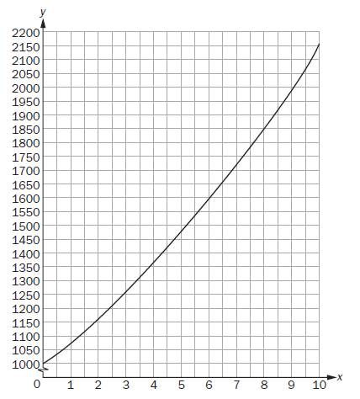
35. A sample of 1,000 bacteria becomes infected with a virus. Each day, one-fourth of the bacteria sample dies due to the virus. A biologist studying the bacteria models the population of the bacteria with the function P(t) = 1,000(0.75)^{t}, where t is the time, in days.  What is the range of this function in this context? | 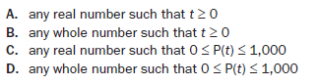
36. The graph shows the height, y, in meters, of a rocket above sea level in terms of the time, t, in seconds, since it was launched. The rocket landed at sea level.  What does the x-intercept represent in this situation?  A. the height from which the rocket was launched  B. the time it took the rocket to return to the ground  C. the total distance the rocket flew while it was in flight  D. the time it took the rocket to reach the highest point in its flight | 