Solving Systems of Equations by GRAPHING
Graph each system and determine the number of solutions that it has. If it has one solution, name it.
1. y = x + 2 2. x + 3y = –3
x – y = –2 x – 3y = –3
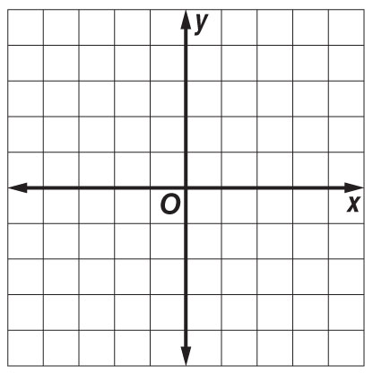

3. y – x = –1 4. x – y = 3
x + y = 3 x – 2y = 3
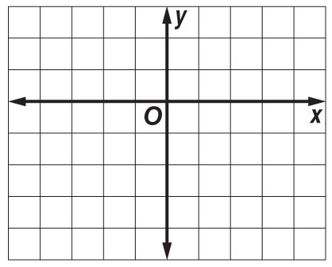

5. x + 2y = 4 6. y = 2x + 3
y = $\frac{1}{2}$ x + 2 3y = 6x – 6

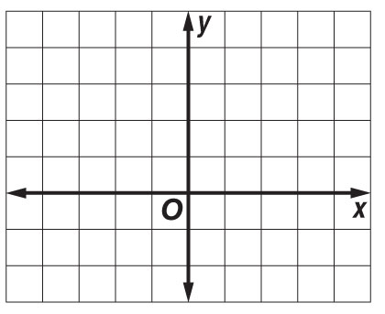

Solving Systems of Equations by ELIMINATION

7. 2p – 3r = 6 8. 6w – 8z = 16 9. c + d = 6
–2p + 3r = –6 3w – 4z = 8 c – d = 0

10. 2u + 4x = –6 11. 3a + b = –1 12. 2x + y = 6
u + 2x = 3 –3a + b = 5 3x – 2y = 16

13. 3y – z = –6 14. c + 2d = –2 15. 3r – 2t = 1
–3y – z = 6 –2c – 5d = 3 2r – 3t = 9

16. The sum of two numbers is 12. The difference of the same two numbers is –4. Find the numbers.

17. Twice a number minus a second number is –1. Twice the second number added to three times the first number is 9. Find the two numbers.

