**Determine whether each relation is a function. Explain how you know.**

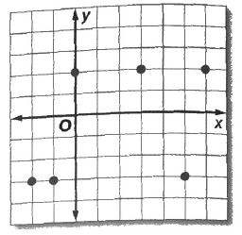

1. {(5, -7), (6, -7), (-8,-1) (0,-1)} 2.

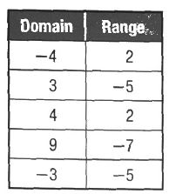

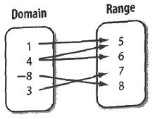3. 4.

Use the following for problems 5- 11. If f(x) = 6x + 7 and g(x) = $x^{2}$– 4 find each value.

5. f(-3) 6. f (2) 7. g(5) 8. g(-5)

**Graph the following system of equations to find the solution**.

9. 10. 

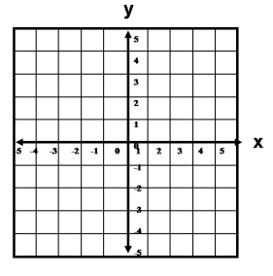

11. 

12. Solve the following system with elimination.

