**GSE Algebra Name _________________________________________**

**Unit 3 Test 3 Date ____________________________ Period _______**

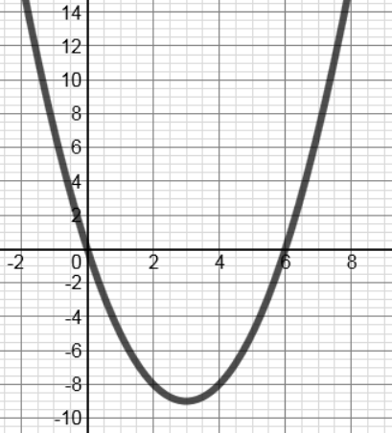Use the graph below to answer questions 1-5.

1. Which of the following equations is a potential equation for the graph?
   1. 
   2. 
   3. 
   4. 
2. The function is **decreasing** on which of the following intervals?
   1. 
   2. 
   3. 
   4. 
3. What are the domain and range of the graph above?
   1. Domain: ; Range: 
   2. Domain: ; Range: All Real Numbers
   3. Domain: All Real Numbers; Range: 
   4. Domain: All Real Numbers; Range: 
4. Which of the following describes the transformation of the function above from the parent function ?
   1. Right 3, Down 9
   2. Right 3, Up 9
   3. Reflection over the x-axis
   4. Reflection over the y-axis
5. The symmetry of the function above can be described as
   1. Odd
   2. Even
   3. Neither
   4. Symmetric about the x-axis.
6. The equation for the axis of symmetry of the function  is
   1. 
   2. 
   3. 
   4. 
7. The y-intercept of the function  is
   1. (0, -1)
   2. (0, 4)
   3. (0, -9)
   4. No y-intercept
8. Which of the following equations translates the parent function as follows:

***Up 5, Right 2, Vertical Stretch of 3***

* 1. 
  2. 
  3. 
  4. 

1. The transformations of the equation  can be described:
   1. Reflection over the x-axis; Right 1
   2. Reflection over the y-axis; Left 1
   3. Reflection over the y-axis; Right 1
   4. Reflection over the x-axis; Left 1
2. The transformations of the equation  can be described:
   1. Vertical Stretch 4/5; Right 8
   2. Vertical Shrink 4/5; Down 8
   3. Left 4/5; Down 8
   4. Vertical Shrink 4/5; Left 8
3. Which of the following points is the vertex of the function 
   1. (3, 6)
   2. (2, -6)
   3. (2, 6)
   4. (-2, 6)
4. Find the x-intercepts of the function 
   1. (-7, 0) and (-1, 0)
   2. (-5, 0) and (-2, 0)
   3. (10, 0) and (1, 0)
   4. (5, 0) and (2, 0)
5. Find the Rate of Change on the interval [-1, 2] for the function . Show your work!

Use the function  to answer questions 14-16. Show your work!

1. Find the equation for the axis of symmetry.
2. Find the vertex.
3. Find the y-intercept.
4. Use the graph below to describe the characteristics of the function 

|  |  |
| --- | --- |
|  | Domain: ___________________________________  Range: ____________________________________  Interval(s) of increase: ______________________  Interval(s) of decrease: _____________________  Maximum: _______________________________  Minimum: ________________________________  Axis of Symmetry: ___________________________  x-intercept(s): ______________________________  y-intercept: ________________________________  Even/Odd/Neither: _________________________  What is the end behavior?  As ,  As , |

1. Use the graph above to find the rate of change on the interval [0, 1]. Show your work.
2. Cassie dove into a swimming pool from a 6- foot-high diving board with an initial upward velocity of 46 feet per second. Use the model for vertical motion given by the equation  , where h is the height in feet and t is the time in seconds.
   1. After how many seconds did Cassie hit the water?
   2. At what time was Cassie at the highest point?
   3. What was the highest point Cassie reached?

For questions 20 – 23: Describe all transformations of each function from the parent function f(x) = x2.

1. 
2. 
3. 
4. 

For questions 24-27: Write an equation for each function below based on the given transformations from the parent function f(x) = x2.

1. Up 8
2. Left 7, Down 9
3. Reflected over the x-axis, vertical stretch of 5.
4. Vertical shrink of 1/3, Right 4, Down 1

**Extra Credit: DUE TOMORROW Name ___________________________________**

1. Find the length and width of a rectangle whose area is 4 square feet and whose length is 3 feet more than the width.
2. Given the equation  find each of the following:
   1. Range:
   2. Interval of Decrease:

**Extra Credit: DUE TOMORROW Name ___________________________________**

1. Find the length and width of a rectangle whose area is 4 square feet and whose length is 3 feet more than the width.
2. Given the equation  find each of the following:
   1. Range:
   2. Interval of Decrease: