Name: ____________________________________ Date: _______________ Period: _________

GSE Algebra 1 Unit 4 Test 1 Review (R)

**Unit 4 Test 1 Review**

**Simplify each expression. Write your answers using only positive exponents.**

1. 
2. 
3. 

|  |  |  |
| --- | --- | --- |
|  |  |  |

Exponential Equation 

1. Consider the following exponential function 
2. Does the function model exponential growth or decay? How do you know?
3. What is the initial value of the function? c) What is the Horizontal Asymptote? (Y= ?)

**Graph each function using 3 points, graph the horizontal asymptote, and state all of their characteristics**

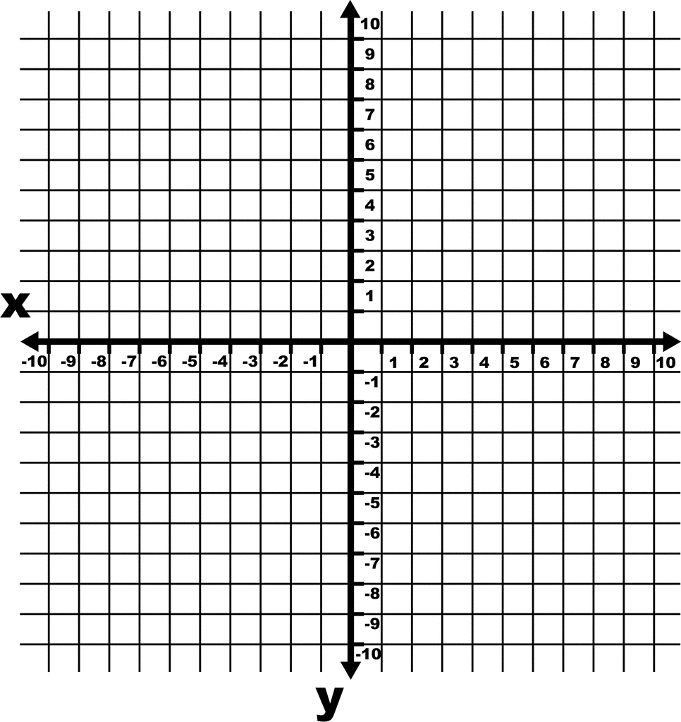8. 

1. Growth or Decay? ______________ b) Domain: ___________

1. Range: _________ d) H. A: ____________

e) y – intercept: ____________________

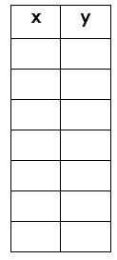

9. 

1. Growth or Decay? ___________ b) Domain: ___________

1. Range: _________ d) H. A: ____________

e) y – intercept: _________________________

g) Increasing: __________

h) Decreasing: __________

i) End Behavior:

As x $→∞$, y $→$

___________

As x $→-∞$, y $→$

__________

Describe all transformations of each function below from the parent function f(x) = 3x.

10.

11. 

12.

13. 

14.

15.

Write an equation for each function below based on the given transformations from the parent function

f(x) = 5x.

16. Translation up 4 units.

17. Reflected across the x-axis.

Translated down ½ units.

18. Stretched vertically by a factor of 5.

Translated right 8 units.

Translated down 10 units.

19. Vertical shrink by a factor of 2/5.

Reflected across the x-axis.

Translated up 12 units.

Translated left 3 units.

Given the graph of f(x) in each graph below, graph g(x) on the same graph. Then, state the properties of the new graph, g(x).

20. f(x) = 3x  Already Graphed. You need to graph g(x) = 3x + 2

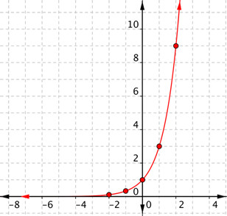

Domain: ________________

Range: ________________ _

Horizontal Asymptote: ______________

21. f(x) = 2x  Already Graphed. You need to graph g(x) = 2x – 3.

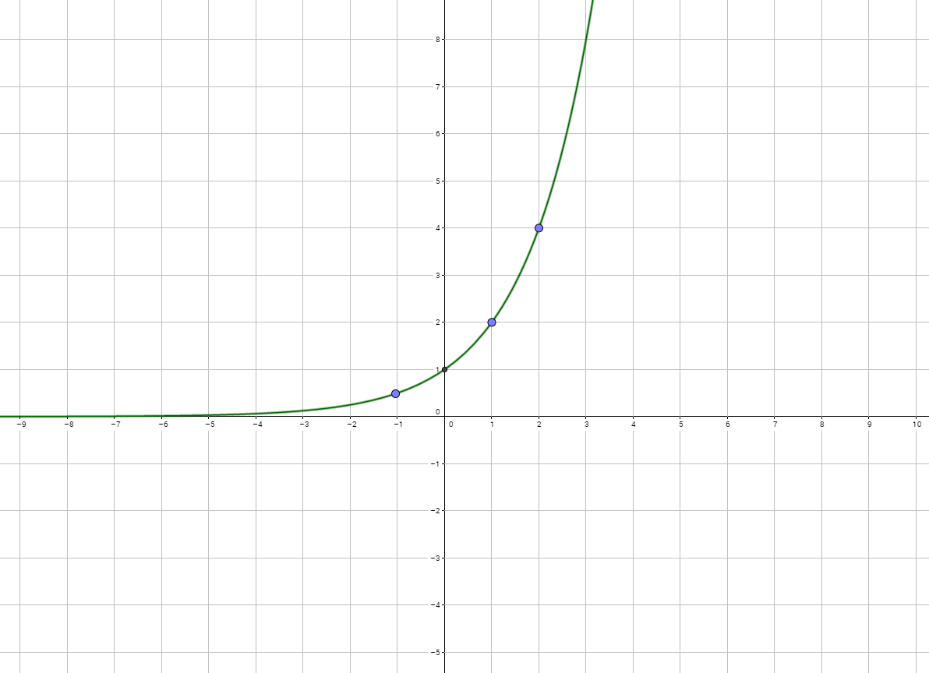

Domain: ________________

Range: ________________

Horizontal Asymptote: ______________