**Algebra Unit 6 – Describing Data**

**Day 7 Box and Whisker Plots – Notes**

A Box and Whisker Plot, also known as a ___________ _____________, is a graphical display that organizes data values into ____________________ or groups.

**Quartiles**

The ________________ of a set of a data separates the data into two equal parts. Data can further be separated into quartiles.

Quartiles separate the original set of data into ____________ equal parts. Thus, each of these parts contains one – fourth of the data, or 25% of the data.

[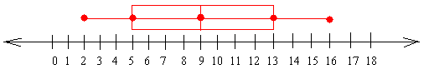](http://www.google.com/url?sa=i&rct=j&q=&esrc=s&frm=1&source=images&cd=&cad=rja&docid=b1TcX7zXRI5KUM&tbnid=-K0r6w_fdUeo3M:&ved=0CAUQjRw&url=http://www.basic-mathematics.com/box-and-whiskers-plot.html&ei=vHQCU575HK_fsATJs4GgCg&bvm=bv.61535280,d.aWc&psig=AFQjCNHIavQdbThM-AUdlTV67fjXmmd2SA&ust=1392756169716867)

**Five Number Summary**

To create a box plot, we need to know the ________ ___________ _________________. The Five Number Summary consists of the following:

* Minimum:
* Lower Quartile (Q1):
* Median (Q2):
* Upper Quartile (Q3):
* Maximum:

**Find the five number summary for each data set listed below:**

a) 35, 35, 37, 40, 43, 56, 58, 58, 60 b) 85, 100, 97, 84, 73, 89, 73, 65, 50, 83

c) 4, 6, 5, 6, 2, 7, 6, 8 d) 102, 78, 312, 170, 250, 40, 52, 38, 125

**Constructing a Box and Whisker Plot**

**Ex 1:** Construct a box and whisker plot for the following math test scores 80, 75, 90, 95, 65, 65, 80, 85, 70, 100.

Step 1: Write the data in numerical order.

Step 2: Find the five number summary.

Min: Q1: Median: Q3: Max:

Step 3: Place a circle above each of these values on the number line.



Step 4: Draw a box around the first and third quartiles, draw a vertical line through the box at the median, and draw the whiskers (or lines) from each end of the box to the minimum and maximum value.

**Now answer the following questions about your box plot…**

1. What percent of the data is below the median? ­
2. What percent of the data is below Q1 (Lower Quartile)? What does this mean in the context of the problem?
3. What percent of the data is below Q3 (Upper Quartile)? What does this mean in the context of the problem?
4. What percent of the data is above the median? What does this mean in the context of the problem?
5. What percent of the data is above Q1? What does this mean in the context of the problem?
6. What percent of the data is above Q3? What does this mean in the context of the problem?
7. What percent of the data is in the box? What does this mean in the context of the problem?

**Ex 2:** Construct a box plot for the following data set 85, 100, 97, 84, 73, 89, 73, 65, 50, 83, 79, 92, 78, 10



**Box and Whisker Plot - Homework #1**

1. Create a box and whisker plot using this data: 14, 6, 13, 17, 1, 12, 9, 18. **Show all your work when finding the Five Number Summary.**



2. Create a box and whisker plot using this data: 77, 99, 112, 85, 117, 68, 63. **Show all your work when finding the Five Number Summary.**



**3. The box-and-whisker plots below show a class’ test scores for two tests. What conclusions can you make?**

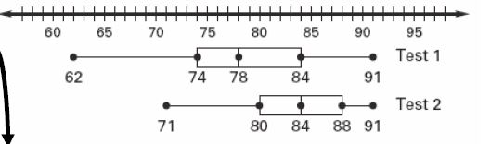

The _____________________ are the same for both tests.

The median for the second test is _______________ than the median for the first test.

The ____________________ for the first test is the same as the ______________ for the second test.

The scores for the ________________ are more spread out than the scores for the _____________.

What is the Five Number Summary for Test 1? Test 2?

Find the range for both tests. Which test had a higher range of scores? Explain what this means.

**4. For the following data, calculate the desired information. Then, create box-and-whisker plot**

**19, 27, 19, 24, 21, 20, 23, 29, 25, 26, 33**

Order the numbers from least to greatest:

Minimum: Lower Quartile: Median: Upper Quartile:

Maximum: Range: Interquartile Range:



**5. The box-and-whisker plots show the weights of electric handheld power blowers and gasoline handheld power blowers.**

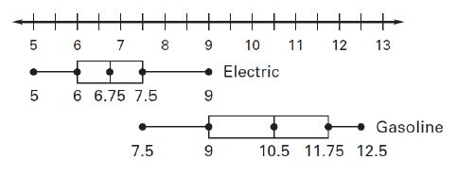

a) Compare the median, range, and interquartile range for the two types of blowers.

b) About what percent of electric blowers are less than 7.5 pounds?

c) About what percent of gasoline blowers are more than 10.5 pounds?

d) Which type of blower would you say is the “lighter” blower? Explain.

[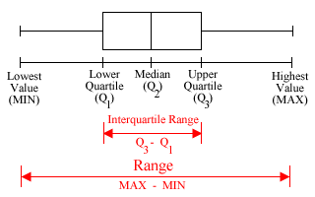](http://www.google.com/url?sa=i&rct=j&q=&esrc=s&frm=1&source=images&cd=&cad=rja&docid=Zwkmu2fcupad-M&tbnid=dNxCQKQkc5vgIM:&ved=0CAUQjRw&url=http://cribbd.com/question/how-do-i-make-a-box-and-whisker-plot&ei=TXQCU77eCte-sQT8gYKYBg&bvm=bv.61535280,d.aWc&psig=AFQjCNHIavQdbThM-AUdlTV67fjXmmd2SA&ust=1392756169716867)

**Algebra Unit 6 – Describing Data**

**Day 8 Box and Whisker Plots – Notes**

**Interquartile Range**

The **Range**, and the **Interquartile Range** **(IQR)**, are measures of ______________ for a box and whisker plot.

IQR = Upper Quartile (Q3) – Lower Quartile (Q1)

Range = Maximum – Minimum

**Briefly describe the similarities and differences between the range and the IQR.**

**Construct a box and whisker plot to compare the following sets of data. Then answer the questions that follow**.

Christian wanted to know whether the players on the Chattahoochee basketball team were taller than the basketball players on Northview’s team. He recorded the following heights of basketball players for both teams. CHS's team heights were: {50, 48, 52, 56, 49, 58, 60}. The rival team had these heights {52, 50, 55, 59, 48, 62, 55}.

**Chattahoochee** **Northview**

 

1. Which team had a higher median height?
2. Which team had a higher percentage of players who were above the median height? Describe what this means in the context of the two basketball teams.
3. Which team had a greater IQR? Explain what the IQR means in context.

**Outliers**

*An* ***outlier*** *is a data value whose distance from the upper or lower quartile is more than 1.5 times the interquartile range.*

Lower Fence: $Q_{1}-(1.5)(IQR)$

Upper Fence: $Q_{3}+(1.5)(IQR)$

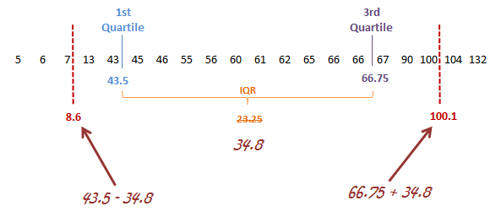

Upper Fence =

Lower Fence =

Example 1: Make a box-and-whisker plot for the following data (snowfall, in inches, of the top ten snowiest cities in the U.S. in a recent year): 100, 129, 105, 97, 112, 103, 156, 110, 117, 98



a) Five number summary:

Min: Q1: Med: Q3: Max:

b) Determine if there are any outliers in the snowfall data set. Explain how you know.

Day 08

**Box and Whisker Plot Homework #2**



1. For the box-and-whisker plot above,
   1. Find the following values:

Maximum: Minimum: Upper Quartile:

Median: Lower Quartile:

* 1. Is there an outlier? Show your work to explain.

(2) Construct a box-and-whisker plot for the following numbers:

1. 16, 12, 13, 14, 16, 18, 15, 17, 20, 12, 14, 15



1. What is the interquartile range? What does this mean?

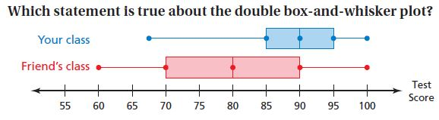(3).

A) Half of the test scores in your class are between 85 and 100.

B) 25% of the test scores in your friend’s class are 80 or above.

C) The medians are the same for both classes.

D) The test scores in your friend’s class are more spread out than the test scores in your class.

(4) The lengths (in inches) of the fish caught on a fishing trip are 9, 10, 12, 8, 13, 10, 12, 14, 7, 14, 8, and 14.

a) Make a box-and-whisker plot for the data on the number line below.



b) What is the range of the data? c) What is the interquartile range?

d) Is there an outlier? Show your work to explain.

.

(5)

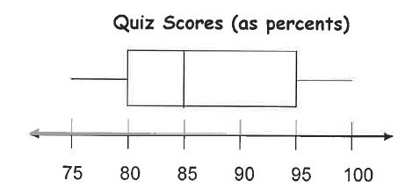

a) What percent of the class scored an 80% or better?

b) What percent of the class scored below 85%?

c) What percent of the class scored between 85% and 95%?

d) What percent of the class scored below 95%?

e) What is the lower quartile?

f) What is the median?

g) What is the interquartile range?

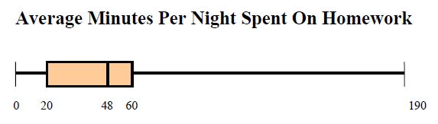(6) Refer to the box & whisker graph below that shows how much time was spent per night on homework for sophomore class at a certain high school during September.

a) What percent of the sophomores spend more than 60 minutes on homework per night?

b) Are there any sophomores who do not do homework?

c) What percent of the sophomores spend less than 20 minutes per night on homework?