GSE Algebra 1 Day 06 - Dot Plots and Frequency Tables HOMEWORK

1. The students in one social studies class were asked how many brothers and sisters (siblings) they each have. The dot plot here shows the results.

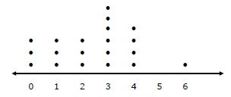

a. How many of the students have six siblings?

b. How many of the students have no siblings?

c. How many of the students have three or more siblings?

2. The resting pulse rates were recorded for 16 boys in gym class before they exercised. The line plot here shows the results.
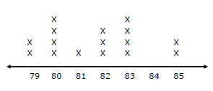

- What is the range of the pulse rates?

- How many boys had a pulse rate over 81?

- How many boys had a pulse rate of 83?

- How many boys had a pulse rate of at most 82?

3. The list shows the average high temperatures for 20 cities on one February day. Make a cumulative frequency table of the data. How many cities had average high temperature below 59 degrees? 69, 66, 65, 51, 50, 50, 44, 41, 38, 32, 32, 28, 20, 18, 12, 8, 8, 4, 2, 2.
February Temperatures in 20 Cities
Average Highs | Tallies | Frequency | Cumulative Frequency
0 – 19
20 – 39
40 – 59
60 – 79

4. The heights of 20 basketball players, in inches, are given below.
68, 70, 70, 71, 75, 80, 81, 82, 84, 75
75, 80, 75, 77, 75, 80, 83, 80, 71, 70

- Complete the frequency table for the data then create a line plot using the number line provided.

Height | 68-70 | 71-73 | 74-76 | 77-79 | 80-82 | 83-85
Frequency

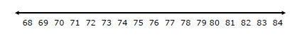

- What is the spread (range) of the data?

- What is the mode of the data?

- How many players are greater than 70 inches tall?

5. The ages of 22 students in a karate class are given below.
11, 5, 9, 13, 8, 9, 9, 11, 10, 8, 6, 7,
12, 11, 13, 12, 7, 6, 11, 12, 10, 8

- Complete the frequency table for the data then create a line plot using the number line provided.

Ages | 5 | 6 | 7 | 8 | 9 | 10 | 11 | 12 | 13
Frequency

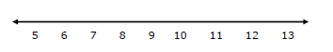

- What is the spread (range) of the data?

- What is the mode of the data?

- How many students are at least 10 years old?

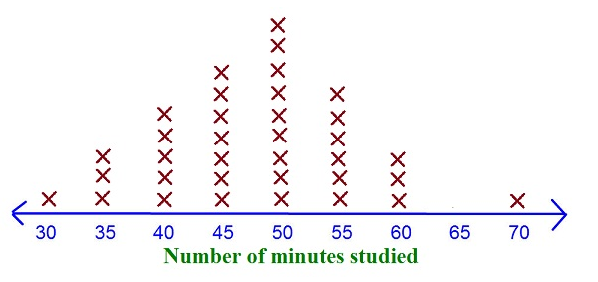
6. Complete the frequency table from the given dot plot.

Minutes | 30 | 35 | 40 | 45 | 50 | 55 | 60 | 65 | 70
Frequency

