GSE Algebra 1 Day 06 - Dot Plots and Frequency Tables Notes
Part 1: Dot Plots
- A ____________________ is a graphical display of data using dots! Put a dot for _______________
data point above the number.
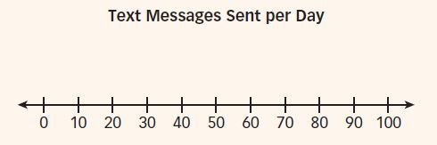
Example 1: A random sample of teenagers ages 13 and 14 were asked: On average, how many text messages do you send per day? Here at the results.
0, 10, 10, 10, 10, 20, 20, 20, 30, 50, 50, 50, 90, 100
- Display the data in a dot plot.

- How many teenagers were surveyed? How do you know?

- Describe the shape of the graph.

- Count the number of dots at 0 and at 10. What do those numbers mean?

d) What is one conclusion you can draw from this dot plot?

Dot plots are best for SMALL data sets. Each dot represents one piece of data in the set.
Practice Problems:
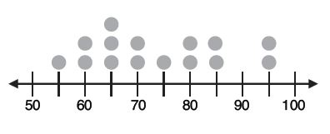
- Ms. Makita made a dot plot to show the scores her students got on a test. At the right is Ms. Makita’s dot plot.

a) What does each “circle” represent?

b) How many students scored at least a 60 but less than an 80?

c) How many students scored over an 85? d) What is the mode?

2. The following dot plot represents scores on a math project in Mr. Jone’s Geometry class.
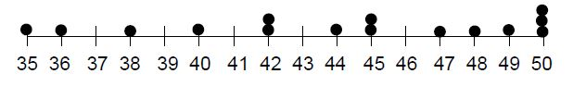

- How many students turned in math projects?

- Determine the mean and the median of the data set.

- Determine the mode of the data.

- The following data shows the number of medals won per country during the 2006 Winter Olympics.
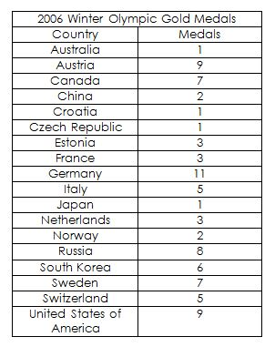
- Make a dot plot for the data

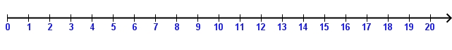

- Describe the shape of the graph

What can you conclude from the dot plot?

- Nathan asked his classmates to estimate the number of hours they spend doing homework each week. The following data shows the results of his survey.

9, 4, 8, 2, 7, 3, 5, 6, 1, 4, 7, 6, 8, 5, 6, 5, 6, 7, 11, 14, 6

a) Make a dot plot for the data set.

b) Determine mean, median, mode, and range for the data.

c) Describe the shape of the graph. d) Does there appear to be any gaps/outliers?

Part 2: 1-Way Frequency Tables
_____________________________________ refers to a table of the data which only examines one categorical variable at a time.
A Frequency Table is a table that lists items and uses tally marks to record and show the number of times they occur.
Example 1 The following frequency table shows the number of grade 2 students who chose Taco or Burger as their favorite food.

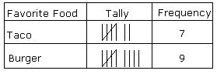

- Mr. Smith made a frequency table of the scores his students got on a test.

Score | Freq | Cumulative Frequency
Below 75 | 4 | 4
76-80 | 14 | 18
81-85 | 3 | 21
86-90 | 8
91-95 | 5
96-100 | 1
- How many students scored more than 85%?

- Do you know how many students scored a 94?

- Complete the cumulative frequency column.
- Display each set of data in a frequency table.

- 5 1 4 6 2 6 4 5 1 3 2 6 4 5 4 6 b) 4 3 1 2 1 3 3 1 3 2 1
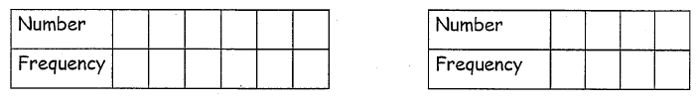

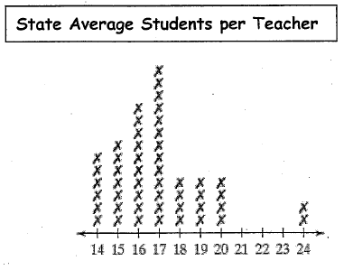
- Construct a frequency table from the box plot below.

