**STUDY GUIDE - FINAL EXAM**

1. What is the solution set for the system of equations by substitution ? 
2. In a supermarket, each orange costs $3, and each apple costs $2. If you want to spend exactly $45, write an equation in standard form modeling this situation. Let o represent the number of oranges you buy, and a represent the number of apples you buy.
3. If you spent $21 and you purchased 3 apples, how many oranges did you buy?

**Solve the following quadratic equations for #4 – 7 by zero product or Solving the equation.**

1.  **5.** 

**6.** 

7. Solve the following system of equations by elimination: 

8. Solve the following system of equations by elimination: 

9. a) Write a function for movie rental deal that charges a flat fee of 20 dollars per month and $1.50 per movie.

b) If your total charge for the movie rental deal is $42.50, how many movies did you rent?

[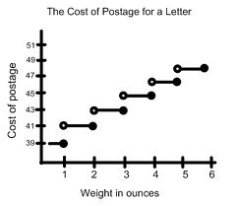](http://www.google.com/url?sa=i&source=images&cd=&cad=rja&docid=GRGmB5kKm6S8uM&tbnid=R2emJciBQQRpxM&ved=0CAgQjRw&url=http://www.algebra-class.com/step-functions.html&ei=9pEGU6zcKoTvkQfIu4GoBw&psig=AFQjCNFhRVZiJX_yrlbwpB938Es4XgL8iQ&ust=1393025910810384)

10. The graph to the right shows the cost of postage to mail a letter. If your letter weighs 5.5 ounces, how much would you pay for the postage?

1. The length of daylight for Houston, Texas for the following days are shown. Which month has the longest day? __________________

Which Month has the shortest day? ____________

1. As one of his 2017 goals, Peter decided he wants to walk to work. The graph below represents Peter’s distance to work and the time it takes for each part of his trip.

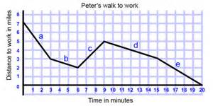

1. Using the slope formula, What is the slope of segment d?
2. Using the slope intercept formula, What is the equation of segment d?
3. What is the domain of Peter’s walk?
4. What is the range of Peter’s walk?
5. Solve for the unknown side length in each triangle below. (Hint – SOH-CAH-TOA)

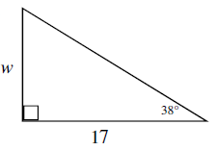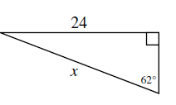

1. b

**For questions 14-15, use the following information:**

Toni is graduating with a degree in English. She has 2 job offers.

* The first job is at a local bank to create the company newsletter and other inside communications. She has been offered a salary of $48,325 per year.
* The other job is with a local newspaper. The journalist position pays $20.50 per hour. She would work five 8-hour days per week although the actual days she works would alternate every week. (assume 52 weeks per year)

1. Find the gross monthly income for the newspaper job.

To determine the after tax income for each job, use the following:

* The U.S. government will deduct Social security (6.2%), Medicare (1.45%), & Income tax (11%).
* Also, she will pay 3% for state income tax. **Total taxes taken out – 21.65%**

1. Find the after tax monthly income for the bank communications job.

1. What is the minimum number of colors you would need to color the map?

**1**

**2**

**3**

**4**

**5**



1. What is the definition an Euler Circuit?





1. List the vertices of both an Euler and Hamiltonian Circuit for the graphs below.

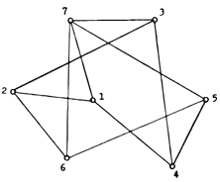

A

D

C

B

h



**Use the following situation for questions 19-22:**

Aaron wants to join a karate dojo. The cost of membership is $25 per month and then there is an $20 fee for each lesson.

1. List the cost of 0 through 5 sessions as a sequence.
2. Write a recursive rule describing the cost of membership and training sessions. C = cost d = number of training sessions
3. Write an explicit rule for the cost of taking ***d*** personal training sessions.
4. How much does it cost Aaron to have 11 training sessions?

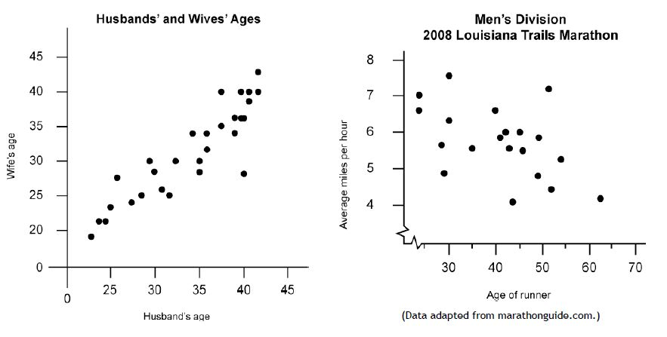

**Use the following graph for questions 23 & 24:**

1. Describe the form of the graph. Does it have a linear or nonlinear pattern?
2. Describe the direction of the graph. Does it exhibit a positive relationship, a negative relationship, or neither?
3. What is the 8th term in the linear sequence *y* = 9 + 21*n*?