Name: ____________________ Date: _________ Period: _______
Probability: Determining Probabilities
II.A Student Activity Sheet 1: Using Venn Diagrams

Ms. Snow conducted a survey of her homeroom. She asked students what math course and what science course they were taking this semester. Below are the results.

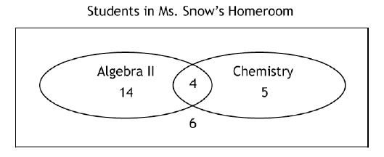
1. Analyze the data in the Venn diagram and list five facts that you can determine about Ms. Snow’s homeroom.

I)

II)

III)

IV)

V)

2. Use mathisfun.com to answer the following:
- What is probability?

- How do you find it?

3. If a student is selected at random from Ms. Snow’s homeroom, what is the probability that the student is taking both Algebra II and Chemistry? Explain your reasoning.

4. If a student is selected at random from Ms. Snow’s homeroom, what is the probability that the student is not taking Algebra II or Chemistry? Explain your reasoning.

5. Find the probability P(Algebra II or Chemistry). Explain your reasoning.

6. Use mathisfun.com to answer the following:

- What is conditional probability?

- How do you find it?

7. Find the probability of a student taking Chemistry, given that the student is not taking Algebra II, or P(Chemistry/not taking Algebra II).

Students survey 758 spectators at a national championship tennis match. The survey results
indicate the following:

• 421 are male,
• 256 have a two-handed backhand swing, and
• 176 of the people with a two-handed backhand swing are female.

Label the Venn diagram using the data provided.

Male
Two-Handed Back Swing

8. What is the probability that a person selected at random from the survey group is male?
Explain your reasoning.

9. What is the probability that a person selected at random from the survey group is
female? Explain your reasoning.

10. What is the probability that a person selected randomly from the survey group has a two -handed backhand swing? Explain your reasoning.

11. What is the probability that a person selected randomly from the survey group is a male
or has a two-handed backhand swing? Explain your reasoning.

12. What is the probability that a person selected randomly from the survey group does not
have a two-handed backhand swing, given that the person is male, or P(no two-handed
backhand/male)?

13. REFLECTION: Describe the characteristics of a situation that suggest the usefulness of a
Venn diagram as a model of the situation.

14. EXTENSION: Describe a situation that could be modeled with a Venn diagram and
create the diagram. Use the diagram to determine the probability of at least two
events that are possible in the situation.

