Name: _______________________________ Date: _____________ Period: _____
Probability: Determining Probabilities
II.A Student Activity Sheet 2: Using Tree Diagrams

Watch the first little bit of the video on tree diagrams at http://study.com/academy/lesson/tree-diagrams-in-math-definition-examples.html

- What is a tree diagram? (study.com)

- What is probability tree diagram? (mathisfun.com)

A church group in Washington state sells pumpkins every year to raise money for the children of their town. This year’s crop, however, produced very small pumpkins. The group decided to construct a corn maze in a field and charge customers to walk through the maze. Customers can only walk forward. If the customers end up at an exit with pumpkins, they win a pumpkin. The church group asked some students to advise it on various possibilities of a customer getting a pumpkin.

Students were shown a simple maze as an example.
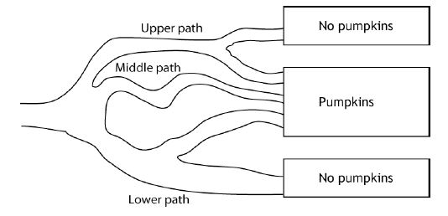

- Make a tree diagram to show the group the possible paths customers might take, entering the maze on the upper, middle, or lower path and proceeding to an exit with or without a pumpkin.

- How is this tree diagram different from others you have worked with before?

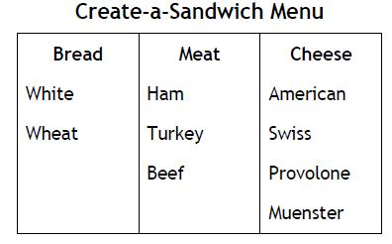
5. Create a tree diagram showing all possible sandwiches.

Assume that you make all the possible sandwich combinations that you can using one choice from each column of ingredients in the table (bread, meat, cheese). Then someone puts all these different sandwiches in unmarked sacks on the counter. Given this information,
answer Questions 6–10?

6. What is the probability you will select a sandwich with white bread? Explain your reasoning.

7. What is the probability you will select a sandwich with American cheese? Explain your
reasoning.

8. What is the probability that you will select a sandwich on wheat bread with ham and any
cheese? Explain your reasoning.

9. What is the probability you will select a sandwich on white bread that has either beef or
turkey and has Provolone cheese? Explain your reasoning.

10. What is the probability you will select a sandwich with neither beef nor Muenster cheese?
Explain your reasoning.

11. REFLECTION: Write three probability questions that can be answered using your tree
diagram, and then provide the answers.

Name _______________________________ Date _________________

Tree Diagrams Homework

As president of the high school band, Catrina needs to pick a committee of 2 to accompany her each time she visits middle schools. The director told her that each committee had to consist of 1 boy and 1 girl; 5 boys and 4 girls volunteered to go. To be fair, Catrina makes a spinner with the boys’ names and a spinner with the girls’ names. Each time she schedules a visit, Catrina spins each spinner once to determine who goes with her. If a spinner lands on a line, she spins again.

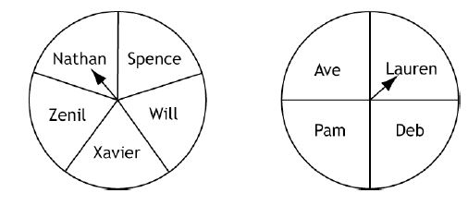

1. Draw a tree diagram to show all the possible combinations of volunteers who might go
with Catrina. How many outcomes are in the sample space?

2. Are all the outcomes equally likely? What would make the outcomes not equally likely?

3. What is the probability that Nathan will be selected? Explain your reasoning. List the
possible outcomes for 2-person committees that include Nathan.

4. If Ave decides she cannot go on a visit she is scheduled for, how does this change the
probability for other boys or other girls to be selected? Explain your reasoning.

