Name: ___________________________________ Date: _____________ Period: _____
Probability: Determining Probabilities
II.A Student Activity Sheet 3: Using Area Models

Recall the rules for the pumpkin problem you looked at in Student Activity Sheet 2 with a tree diagram: A customer walks forward through the maze with the possibility of winning a pumpkin; this depends on whether there is a pumpkin at the exit where they come out of the maze. One student, Kyra, draws an area model that demonstrates the probability of getting a pumpkin using this maze.

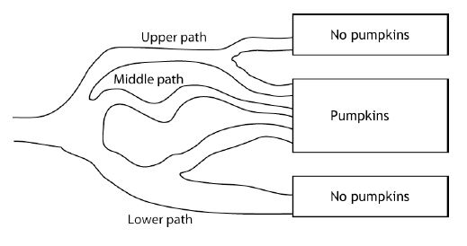
Kyra explains, “As customers enter the maze, what are the path possibilities? They can take the upper path, middle path, or lower path. These three options lead you to divide the area model into three sections. Next, look at each path and decide how to divide each section. The upper path divides into two paths, the middle path stays one path, and the lower path divides into two paths. Next, decide which part of the model of the maze gets a pumpkin and which part does not.”
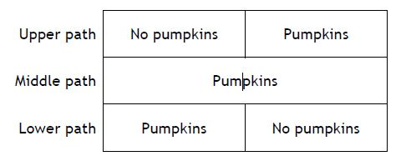

The probability of getting a pumpkin is $\frac{2}{3}$, and the probability of not getting a pumpkin is $\frac{1}{3}$.

1. How does the area model Kyra created compare to the tree diagram from your work in Student Activity Sheet 2?

2. Design another possible maze the group might create, perhaps with more branches, and use an area model to show the possible outcomes. Try out your maze with other
classmates to see if they are able to draw an appropriate area model. Below is a drawing of a second maze the church decided to construct.

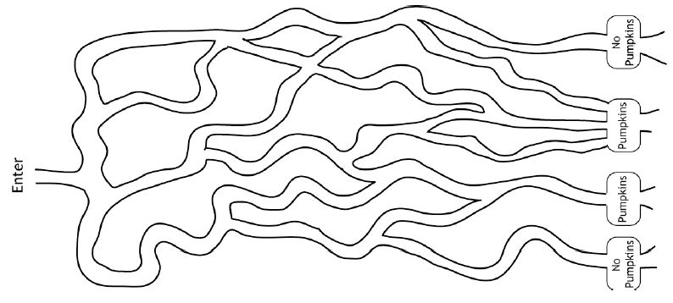

3. Use an area model to determine the theoretical probability of a customer taking home a pumpkin.

Probability of getting a pumpkin = P(Pumpkin) =

4. If 50 customers enter the maze, how many pumpkins do you expect to give away? Explain your reasoning.

5. The maze has six exits. If you want to give away a lot of pumpkins, at which three exits do you put the pumpkins? Explain your reasoning. (Hint: Number the exits 1 through 6, and have the area model show where the path ends.)

6. If you do not want to give away too many pumpkins, at which three exits do you put the pumpkins? Explain your reasoning.

7. REFLECTION: What would a maze look like with equally likely outcomes? What would the corresponding area model look like? What is an advantage of the area model?

8. EXTENSION: Because this year’s maze was such a success, Emma draws a plan for next year.

• Y—The customer gets a pumpkin.
• N—The customer does not get a pumpkin.
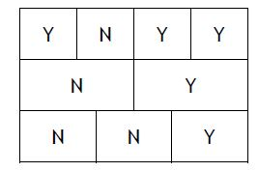

a. Find P(Y). Explain your reasoning. b. Find P(N). Explain your reasoning.

