AMDM Unit 2 Test Review--Probability (R) Name______________________________________________

Remember to show all work! Round answers to the nearest 2 decimal places or simplest fraction form.

Use the following situation to answer #1-5 Jake gave a survey to 150 seniors at his school. In the survey, he asked the seniors if they used Facebook, Twitter, both, or neither. Here is a Venn diagram that models the results.

Seniors
23
54
28
Twitter Users
Facebook Users

- What is the probability that a senior uses Facebook AND Twitter?

- What is the probability that a senior is not a Facebook user?

- What is the probability that seniors are Facebook users but not Twitter users?

- What is the probability that seniors are neither Facebook users nor Twitter users?

- What is the probability that a student is a Twitter user given that he/she is a Facebook user?

Use the following situation to answer #6-12 Every morning, Neil eats either a bagel or toast for breakfast. Neil has three choices of jam to choose from: grape, orange, or strawberry. He also chooses between bacon and sausage as a side. Neil randomly chooses a bagel or toast, the flavor of jam, and his side of bacon or sausage.

- Draw a Tree diagram to match the situation.

- How many possible combinations can Neil choose?

- If Neil chooses a bagel with strawberry jam or orange jam and bacon for breakfast, what’s the probability that his mom chooses the exact same breakfast?

- What is the probability that Neil chooses bacon for breakfast?

- What is the probability that Neil chooses toast with grape jam?

- What is the probability that Neil chooses a bagel with strawberry jam and sausage?

- Given that Neil chooses sausage, what is the probability that he will choose a bagel?

Use the following situation to answer #13-15 At Forsythe Farms, the corn maze has the paths shown. Only some paths have a prize at the end of the path.

- If only forward motion is allowed (no backtracking), draw an area model for the corn maze.

- What is the probability of not winning a prize?

- If 500 people go through the maze on a particular weekend, how many prizes should Forsythe Farms expect to give away that weekend?

- A pizza place surveyed 112 customers to determine their favorite pizza topping or combination of toppings (mushrooms, sausage, and pepperoni). Only 3 people liked all three toppings. Six people liked both pepperoni and sausage. Seven people liked only mushrooms and sausage. Five people liked only mushrooms and pepperoni on their pizza. A total of 37 people liked mushrooms on their pizza, 40 liked sausage, and 46 also liked pepperoni.

a) Draw and label a Venn diagram to represent this situation.
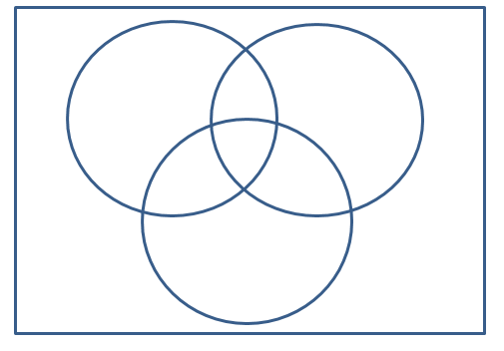
- What’s the probability that a person chosen at random likes sausage?

- Find P(pepperoni and mushrooms).

- What’s the probability that a person chosen at random does NOT like mushrooms?

- Find the probability that a person chosen at random likes mushrooms or sausage.

- Find P(sausage, given that it already has pepperoni).

- Create a table showing the following teacher schedules for math teachers:
Jones- 1st, 2nd, 3rd, 6th, 7th
Fowler - 3rd, 4th, 5th, 6th, 8th
Williams- 1st, 2nd, 6th, 7th
Miller - 3rd, 4th, 7th, 8th
Morning classes will be 1st -5th Afternoon classes 6th-8th

Teacher | 1st Period | 2nd Period | 3rd Period | 4th Period | 5th Period |  | 6th Period | 7th Period | 8th Period

- Create a tree diagram for these Math teachers.

- What is the probability of getting a morning class?

- Before deciding on a morning or afternoon class, Lisa remembered she wants to take her math class during 2nd period. What is the probability she will be scheduled a math class during this time?

- All of the morning math classes are filled & Lisa has a decision to take either Mrs. Fowler or Mr. Williams in the afternoon, what is the probability of Lisa taking a Mrs. Fowler or Mr. Williams in the afternoon?

