AMDM Day 02 Name _______________________
Venn Diagrams Practice Date __________________

- Out of forty students, 14 are taking English Composition and 29 are taking Chemistry.

- If five students are in both classes, how many students are in neither class?

- Label the Venn diagram using the data provided.

- How many are in either class?

- What is the probability that a randomly-chosen student from this group is taking only the Chemistry class?

- At a Halloween party, some of the guests brought cookies, drinks, or candy.
Fill in the Venn Diagram per the following information.
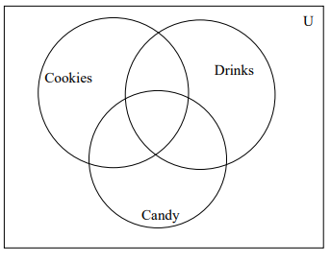
- 5 guest brought cookies, candy and drinks
- 19 guests brought exactly 2 items
- 21 guests brought drinks
- 20 guests did not bring cookies
- 8 guests brought only candy
- 2 guests did not bring a drink or candy
- 5 guests brought only cookies and drinks
- 11 guests brought drinks and candy

Answer the questions on the next page using this Venn Diagram.
- What is the probability that a guest selected at random brought cookies and candy?

- What is the probability that a guest didn’t bring anything to the party?

- What is the probability that a guest brought drinks or candy?

- What is the probability that a guest brought drinks given that they brought cookies?

