Day 12 – Histograms Cheat Sheet Name _____________________________________
Histograms are a great way to show results of quantitative data such as:
- weight
- height
- how much time
If your data is qualitative or categorical, meaning you can split up your data into distinct CATEGORIES, such as country or favorite movie, then you use a bar chart. Notice the difference shown below:
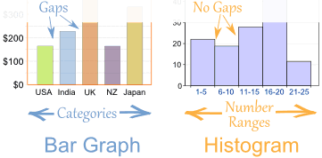
Questions to ask yourself when describing a histogram:
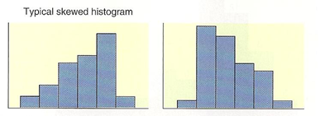
1) What is the shape? (Is it symmetric or skewed?)
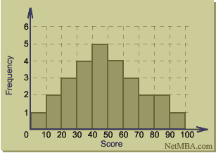

Skewed LEFT Skewed RIGHT SYMMETRIC
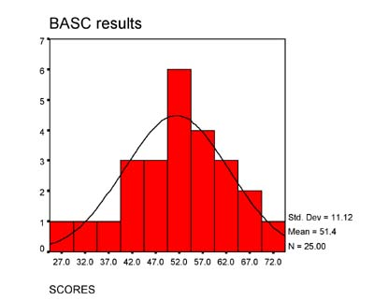
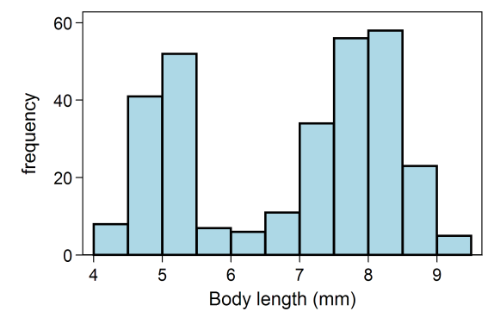

UNIMODAL Distribution BIMODAL Distribution
The center is the median/middle value of a histogram. We can usually approximate this value by looking at the histogram – this is simply a guess as to where we think the midpoint of the data set is located.
Spread - how much variability is in the data? What is the range? How wide is the distribution?
Practice
You asked customers at a local dress shop who bought range of skirts how old they were. You recorded the data that you found in the histogram below. The ages ranged from 5 to 25 years old.
You decide to put the results into groups of 5:
- The 1 to 5 years old range,
- The 6 to 10 years old range,
- etc...
So when someone says “I am 17”, you add 1 to the “16-20” range.

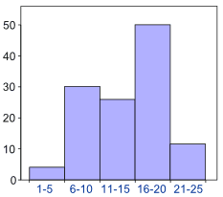

1. How many customers were between 6 and 10 years old?
2. How many customers were between 6 and 20 years old?
3. How many customers were between 0 and 1 year old?
4. How many customers were older than 25?
5. How would you describe the center of this histogram?
6. How would you describe the shape of this histogram?
7. Is this histogram unimodal or bimodal?

