SAS 3A.1 – Overview of Purpose, Design and Study - Day 1 Name: KEY
Statistical investigation is part of an information gathering and learning process which is undertaken to seek meaning from and to learn more about observed phenomena as well as to inform decisions and actions. The ultimate goal of statistical investigation is to learn more about a real-world situation and to expand the body of contextual knowledge.

Since music is a large part of many people’s lives, it is often the subject of study. For example,
- Music industry executives might want to know what will be popular with different age groups.
- Advertisers would want to know which radio stations are the most popular.
- Doctors want to know how much hearing damage results from loud music.

Statistical investigations are used every day for a variety of reasons.

1. Give some examples of statistical investigations with which you are familiar.
-does smoking cause cancer?
-what colors dogs can see?
-does BPA cause cancer?
-does eating fast food cause weight gain?

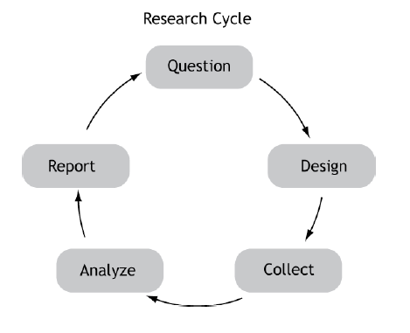
The graphic on the right illustrates the process of planning and implementing a statistical investigation. First, a question (or a series of questions) sparks the interest of a researcher. The research team then decides on the best design for investigating the question.

2. The graphic shows no obvious ending point or starting point. What does this indicate?
-You can essentially start from anywhere, you can change what you're studying or change your mind depending on what you are studying

- The process goes only in one direction but there is no clear starting point. A report that you disagree with or has challenges could be the start. This could generate a new design, requiring more data to be collected, analyzed, and reported.

- Or one question could lead to another question

Consider the following examples of two different types of statistical investigations.

Study 1:  Radio rating services sometimes collect data on listenership by asking participants to record the date, time, and station each time they listen to the radio. Other rating services distribute monitoring devices that automatically record this information anytime the participant has the radio turned on. Still others call participants and ask them about their listening habits. The data are then compiled so that advertisers know which stations are the most popular at specific times during the day.  Observational | Study 2:  A 17-year-old student designed a science fair project with 72 mice randomly assigned to three groups: hard rock music, Mozart, and no music at all. Three times a week, all mice in the first two groups were exposed to music 10 hours a day. Three times a week, all the groups were timed as they ran through a maze. An analysis of results showed that the 24 mice in the no-music group averaged about a 5-minute improvement in their maze completion time, while the Mozart mice improved 8.5 minutes. The hard rock mice actually got slower – an average of 4 times slower! Another interesting fact: The student had to start his experiment over because all the hard – rock mice killed each other. None of the classical mice did that.  Experimental

3. Compare the planning and implementation of the two different types of statistical investigations.
-Study 1 did not use a specific amount of people or time period, but Study 2 used a certain amount of mice and a certain time period.
-Study 1 is survey; OBSERVES the habits of listeners
-Study 1 does not impact the study in any way; only watches what happens
-Study 1 depended on people participating/observed. Interviews people/volunteer.

-Study 2 is experiment; control group (no music)
-Study 2 can see more of trend between the different groups
-Study 2 had multiple tests/trials

-Both: collected data to draw conclusions. Questions were posed to start.

- The first statistical investigations approach is an example of an observational study, which collects data about some characteristic(s) of the population. The data can be collected by observation, by a survey or interview, or by other means.

- The second statistical investigation is an example of an experimental study. In an experimental study, the researcher separates the participants into one or more groups and applies some sort of treatment. After treatment, the variable of interest is measured and the results are compared. This study used a control group. A control group is the group in an experiment or study that does not receive treatment by researchers, and is used as a benchmark to measure how the other tested groups perform.

4. Describe an observational study in your own words. Given another example of an observational study.
-An observational study is a random collection of data about some characteristic of the population through surveying, interviewing, etc., some form of observation. An example is how many people eat fast food for dinner more than once a week. Observing and watching.

5. Describe an experimental study in your own words. Given another example of an experimental study
-An experimental study is when someone does an analysis of a couple different groups and involves introducing a different thing into the lives of people to see what it causes. A control group and treatment are used to gain more info and compare results. An example: does having class inside or outside have an impact on how people do on tests. Making one class have class outside and the other have class inside.

6. What is the control group, treatment and the variable of interest in the experimental study?
Control group: mice with no music
Treatment: music they listened to
Variable of Interest: Does the music have an impact on how fast the mice finish the maze.

Determine whether the following study is observational or experimental. If it is experimental, list the participants, the treatment, how the treatment was assigned, the control group, and the variable of interest. If it is observational, list the participants and what is being observed.

7. Dr. Cole and Dr. Abel want to study the effects on a patient’s arthritis that occur when the patient believes that he or she has used a new ointment. The patients visiting Dr. Cole are given a placebo medicine. The patients visiting Dr. Abel receive the actual medicine.

An experimental study, treatment assigned was the different medicines.
- Participants are the patients visiting both doctors
- Treatment was the new ointment.
- How: picked arthritis patients for fake and real medicine. Dr. Cole’s got the placebo and Dr. Abel’s got the actual medicine.
- Control group: people who got the placebo medicine
- Variable of interest: Does the ointment help with arthritis pain?

