Name: _____________________________ Date: _______________ Period :______________
Day 03 - SAS 2: Recursion and Linear Functions
Warm Up:

1. Scatterplots display ______________________ data. Scatterplots are ______________ functions. (You do NOT connect the dots)

2. Given the following graph, answer the questions below.
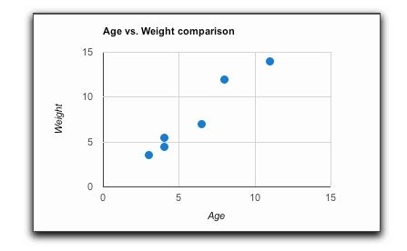

a) What information does the graph above provide?

b) Describe the scatterplot in terms of form, direction, and strength.

c) Can you infer that the older a person is the more he/she weighs?

d) Does the graph display a cause and effect relationship?

3. Read the scenarios below and determine whether it represents correlation or causation.

- A recent study showed that college students were more likely to vote than their peers who were not in school.

- Mr. Corrigan noticed that there was more trash in the hallways after 2nd period than 1st period.

- You hit your little sister and she cries.
4. Read the scenarios below and determine whether it represents positive, negative, or no correlation

- The number of hours workers receive safety training vs. the number of accidents on the job.

- The number of students at Chattahoochee vs. the number of pet iguanas in Atlanta.

- The number of rice dishes eaten vs. the number of cars on I-285 throughout the day.

- The number of calories burned vs. the amount of hours walked

- The number of hours you work and the amount of money you make

Name: _________________________________ Date: ______________ Period: __________
Day 03 - SAS 2: Recursion and Linear Functions
Notes Overview
What is recursion?
- Recursion (A.K.A. Iteration): the determination of a succession of elements (as numbers or functions) by operation on one or more preceding elements according to a rule or formula involving a finite number of steps
- Example
Given the rule “Add 5 then multiply by 2 find the first 6 terms.” Note first term =1.
1,12, 34, 78,166, 342

- You’ve learned about 2 types of recursive sequences in your mathematical career: Arithmetic (Linear) and Geometric (Exponential). Today’s focus is on linear.

- Coen decides to take a job with a company that sells magazine subscriptions. He is paid $20 to start selling and then earns $1.50 for each subscription he sells. Fill in the following table, showing the amount of money (M) Coen earns for selling n subscriptions. Use the process column to show what is happening in each line.
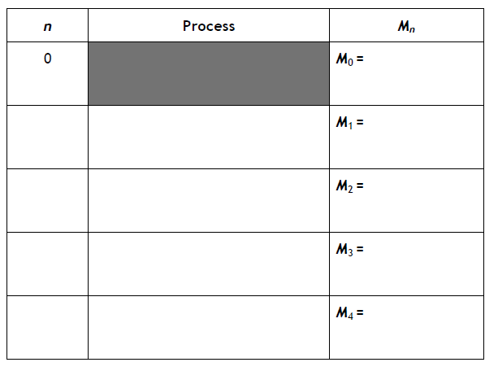

- Write a recursive rule (formula) using the following format for the amount of money Coen can earn selling magazine subscriptions.

______, where n = 0, 1, 2, 3, … and M₀ = _____

What does M_{n+1} represent? What does M_{n} represent?

- REFLECTION: The rule in Question 2 defines a term (M_{n} + 1) with respect to the term that precedes it (M_{n}). Write a rule that defines a term (M_{n}) with respect to the term that precedes it (M_{n} – 1)? How is this rule similar to and different from the rule you wrote in Question 2?

______, where n = 1, 2, 3, … and M₀ = _____

What does M_{n – 1} represent? Now what does M_{n} represent?

- Write an explicit function rule (ex. y = mx + b) for the nth term in the sequence describing the amount of money Coen can earn. Describe any domain restrictions in your rule.

What is the constant/common difference of this function (aka the slope)?

What is the start value (aka the y-intercept/ “b” value)?

Explicit Function Rule for Arithmetic Sequences:

- Describe the scatterplot shown. Be sure to include form, direction, and relative strength in your description.
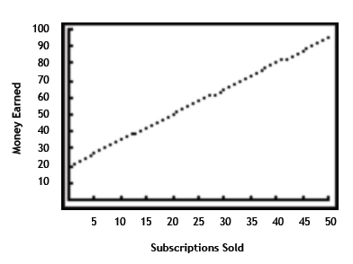
- How much does Coen earn if he sells 100 magazine subscriptions?

Did you use the explicit or the recursive rule to answer this question?

Why did you choose that rule?

- Coen is trying to earn enough money to buy a new MP3 player. He needs $225 to cover the cost and tax on the MP3 player.
- How many magazine subscriptions does Coen need to sell to buy his new MP3 player? Justify your answer.

- Which rule did you use to answer this question? Why did you choose that rule?

- Your phone service allows you to add international long distance to your phone. The cost is a $5 flat fee each month and 3¢ a minute for calls made.

- Write a recursive rule describing your monthly cost for international calls.

- Write an explicit rule for the n minutes of calls made in a month.

