Name: ___________________________ ___________ Date: ________________ Period: ______
SAS 1: Using Scatterplots in Reports Day 02
- When analyzing a display of bivariate statistics, you need to consider the following:
- Form— Does the graph exhibit a linear or nonlinear pattern?
- Direction— Does the graph exhibit a positive relationship, a negative relationship, or neither?
- Relative strength—Are the data points tightly clustered along the line or curve (strongly associated) or are they more scattered (weakly associated)?
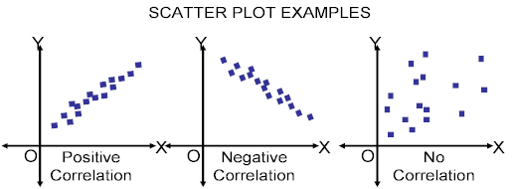

Using the guidelines from number 7, analyze the following graphical displays. Conduct your analysis in the context of the situation.
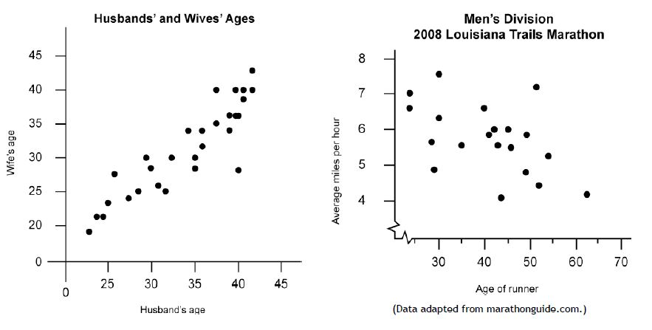
Form:  Direction:  Strength:  Can you make any inferences based on the graphical display? | Form:  Direction:  Strength:  Can you make any inferences based on the graphical display?
- The following graph illustrates the fact that for a designated filing status and taxable income level, the amount of tax owed depends on the number of children.
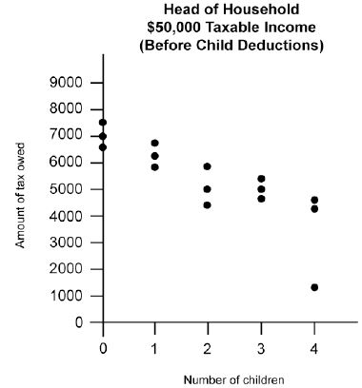

Does this sound like a cause-and-effect relationship or simply a matter of an association between the variables? Justify your answer.

- The graph shown below illustrates that in general older men have wives about their age and younger men have wives about their age.
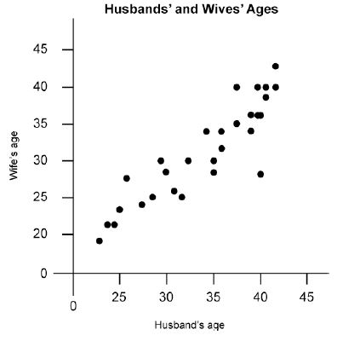

Does this sound like a cause-and-effect relationship or simply a matter of an association between the variables? Justify your answer.

- A news report noted, “As men age, they begin to run slower.” Does this report imply cause and effect or association? What is your opinion of this implication? Explain.
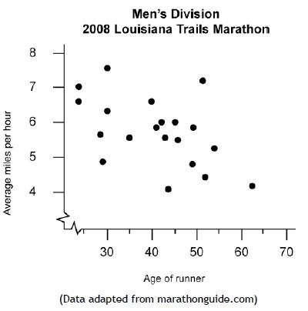

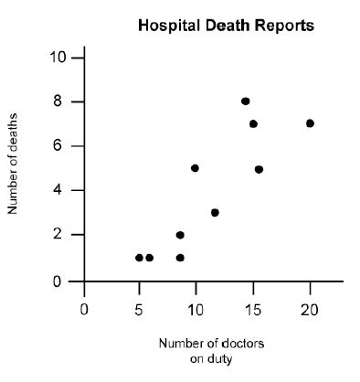
- A special report on the evening news exposed a startling fact: When more doctors are on duty at a hospital, more deaths occur. Does this mean that doctors are killing patients? What are some other explanations?

- In the last 40 years, spending on education has increased, while SAT scores have gone down.
Average SAT scores

a) Sketch a scatterplot that represents these trends.

b) Does increased spending cause a
drop in SAT scores? Explain your reasoning.

$ spent on education

