Name: ___________________________________________ Date: ____________ Period: ________

1. Galaxy Streaming, an internet movie company, offers 2 plans for streaming movies:

Plan A - Each movie costs $2.00 to download.

Plan B Movie Gorge Plan – There is a $10.50 fee per month, and then each movie costs $.50.

* 1. Fill in the table for the cost of each plan:

|  |  |  |  |  |
| --- | --- | --- | --- | --- |
| Plan A | |  | Plan B | |
| # movies | cost |  | # movies | cost |
| 0 |  |  | 0 |  |
| 1 |  |  | 1 |  |
| 2 |  |  | 2 |  |
| 3 |  |  | 3 |  |
| 4 |  |  | 4 |  |
| 5 |  |  | 5 |  |

* 1. Write the recursive rule for each plan.

**Plan A**

**Plan B**

* 1. Write the explicit rule for each plan:

1. **Match the correct description of strength and direction.**

strong positive weak positive strong negative weak negative

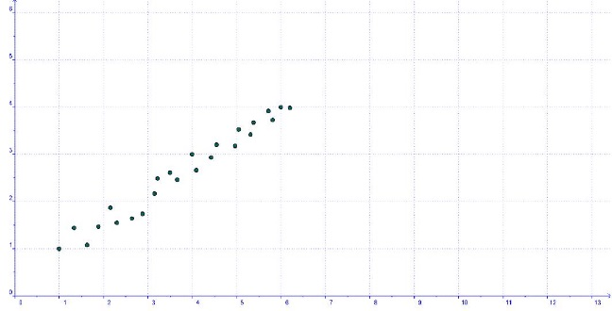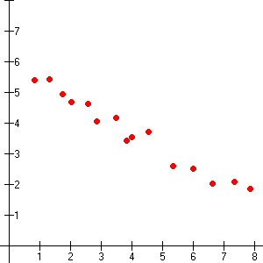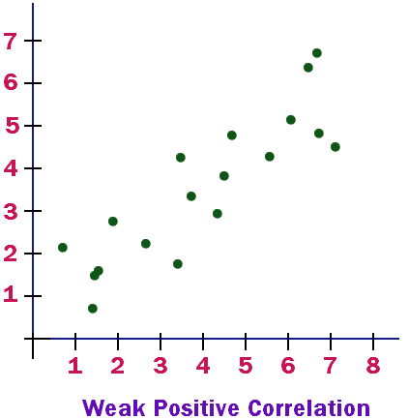

**Given the arithmetic (linear) sequence, write the explicit formula then find the 20th term.**

3. 3, 7, 11, 15, 19, 23, … 4. 110, 103, 96, 89, 82, 75, …

Write the first 3 terms for the following sequences:

5. 

6. 

7. 

8. 

Write the a recursive formula and an explicit formula for each of the following sequences:

9. 

Recursive Formula:



Explicit Formula:



10. 

Recursive Formula:



Explicit Formula:



.Hint: SOHCAHTOA

**Use Trig Ratios to Find the Missing Side or Angle of a Right Triangle**

11.

12.



13.

14.