Name: ___________________________ Date: _______________ Period: _____________
Using Functions in Models and Decision Making: Cyclical Functions
V.B Student Activity Sheet 4: Length of Daylight

You may have noticed that during the winter the days are shorter and during the summer the days are longer. How much longer are days during the summer? Does the length of summer days change depending on the latitude of a place?
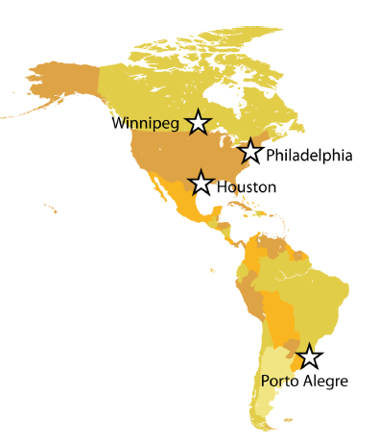
You will investigate these questions using data from five different cities at four different latitudes:

- Atlanta, Georgia — 33°N latitude
• Houston, Texas—30°N latitude
• Philadelphia, Pennsylvania—40°N latitude
• Winnipeg, Manitoba, Canada—50°N latitude
• Porto Alegre, Brazil—30°S latitude (addressed in Student Activity Sheet 5)

The data in the tables for this activity describe the length of daylight for the year 2009. The data table is based on two assumptions:

- The length of daylight is defined as the amount of elapsed time between sunrise and sunset.

• Because 2009 is not a leap year, there are 365 days in the year.

Which city would you expect to have more daylight during the summer, Atlanta or Philadelphia? Why do you think so?

