AMDM Name: __________________________
VB.SAS4 Date: ____________ Period: _______

The following table gives the information about length of daylight for Atlanta in 2012. Convert the hours and minutes into minutes and fill in the last column. (There are 60 minutes in 1 hour.)

Date | Day Number | HH:MM | Min.
Jan. 1 | 1 | 9:58
Feb. 1 | 32 | 10:33
March 1 | 60 | 11:29
Apr. 1 | 91 | 12:34
May 1 | 121 | 13:33
June 1 | 152 | 14:15
July 1 | 182 | 14:21
Aug. 1 | 213 | 13:47
Sept. 1 | 244 | 12:51
Oct. 1 | 274 | 11:49
Nov. 1 | 305 | 10:48
Dec. 1 | 335 | 10:04

1. Make a scatterplot, by hand, of the length of daylight by day for Atlanta.

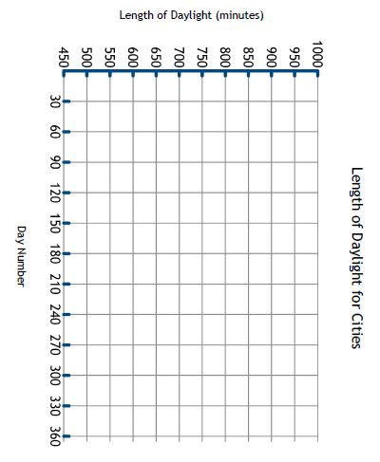

- Give at least TWO similarities from the regression graphs

- Give at least TWO differences from the regression graphs

- Which city had the longest day? How do you know?

- Which city had the shortest day? How do you know?

Maximum: | Minimum:
Day Number: | Day Number:
Date: | Date:
Length of Day in Minutes: | Length of Day in Minutes:

