Name: _____________________________________ Date: _______________ Period: __________
Decision Making in Finance: Future Value of an Investment Practice WS (R)
Unit 6 Student Activity Sheet 2: What Makes Money Work for You?

Ms. Gialenios is analyzing how to invest $500 for 5 years. She is considering the two different types of investments below.

- Savings accounts – Compound Interest 5.00% annually. The Interest amount changes as the balance changes.
.

- Certificate of deposit – Simple Interest 6% annually. The interest is based on the original deposit only.

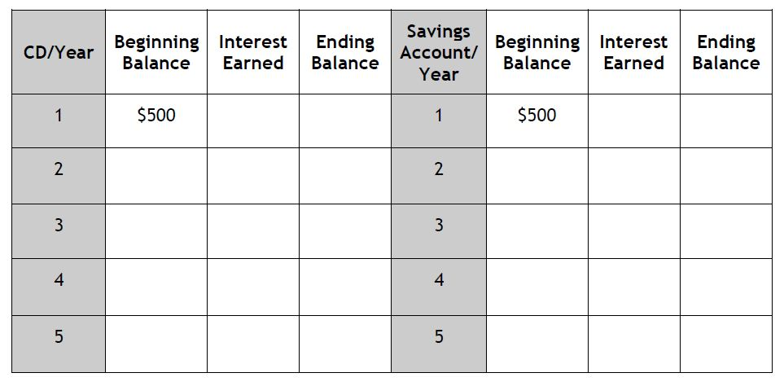
1. Mrs. Gialenios wants to evaluate each investment for the first five years. Use the spreadsheet below to record your calculations.

2. Which investment should Mrs. Gialenios consider investing her money in?
Explain your reason why?

3. Which investment should Mrs. Gialenios invest in if she needs her money for an emergency fund?

