Name: _____________________________________ Date: _______________ Period: __________
Decision Making in Finance: Future Value of an Investment
Unit 6 Student Activity Sheet 2: What Makes Money Work for You?

Amanda is analyzing how to invest $500. She is considering the two investments described below.

- Savings accounts are insured and vary in the way in which interest is calculated. Some accounts pay simple interest, but other accounts compound interest at varying frequencies. Amanda is considering a savings account that pays 3.75% interest compounded annually.

- A certificate of deposit (CD) is an interest-bearing instrument that is similar to a savings account—it is insured and pays interest. Unlike savings accounts, CDs have a fixed time period and usually a fixed interest rate. CDs also vary in the way in which interest is calculated. Sometimes the interest is compounded, but simple-interest CDs also exist. Simple interest is calculated only on the original deposit. The CD must be held until the date of maturity, at which time the original money deposited may be withdrawn with the accrued interest. Amanda is considering a CD that pays 4% simple annual interest for five years.

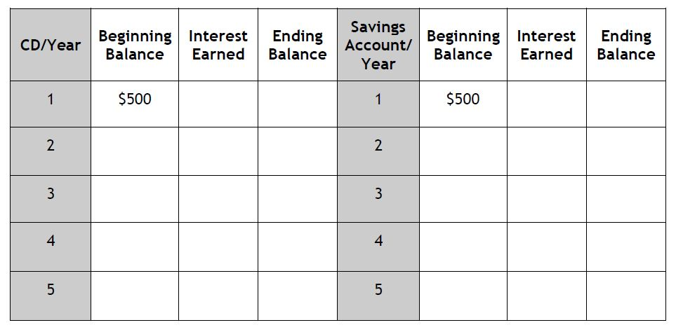
1. Amanda wants to evaluate each investment for the first five years. Use the spreadsheet below to record your calculations.

2. If Amanda is using this investment as an emergency fund, in which should she invest? Explain your reasoning.

3. Based on the processes you used to fill in the spreadsheet in Question 1, write a function rule to model each investment. Let y represent the value of the investment at the end of any year x.

CD Account: ________________________________Savings Account: ________________________________
4. What types of functions did you use to model each investment option? How are the functions related to the type of interest earned in each option?

Amanda has decided to keep the investment until retirement—40 years from now. Assume that she can invest in the same CD or savings account at the same rate for the life of the investment.

5. Use your graphing calculator to graph both functions. Describe your axes and scaling and sketch your graphs.

6. Compare and contrast the graphs of the two different functions. Explain what you see in terms of the function rules and the tables.

7. Why is there a difference between the two models? Explain your answer using the information from the tables, graphs, or function rules.

8. REFLECTION: Which investment should Amanda use: the CD or the savings account? Explain your reasoning.

EXTENSION: One of the greatest contributors to lowering the value of money is inflation, which is a percentage representing the annual increase in the value of money. Find the current annual rate of inflation on the Internet. Consider the investment you recommended for Amanda. Taking inflation into account, what is her actual rate of earning on the investment? Based on your findings, would you make any recommendations to Amanda?

