1. Compare similarities and differences of Euler Paths and Circuits. Is there a quick way to determine whether either of these exist(s)?
2. Compare similarities and differences of Euler and Hamiltonian Circuits.

|  |  |
| --- | --- |
| 3. What is the degree of each vertex?  A_____ E_____  B_____ F_____  C_____  D_____  4. Does a Euler Circuit Exist? If so, find one. | **F**  **E**  **D**  **C**  **B**  **A** |

1. Given the following graphs, circle the best answer.

|  |  |  |
| --- | --- | --- |
| i.   1. Euler Path 2. Euler Circuit 3. Neither | ii.     1. Euler Path 2. Euler Circuit 3. Neither | iii.   1. Euler Path 2. Euler Circuit 3. Neither |

1. Identify the following as Circuits, Paths, or Neither. If it’s a circuit, draw a path to make the circuit.

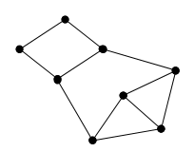

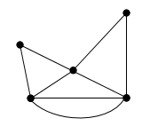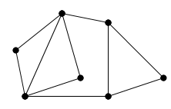

1. Chinese Postman Problem: Find the shortest path that covers all the routes and starts and ends at point A. (Weighted graphs!)

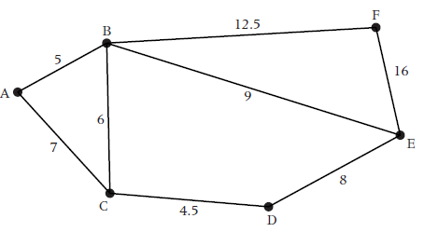 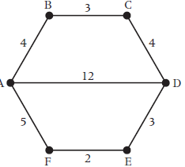

1. What is the minimum number of hours it would take for a snowplow driver to plow all the roads of this town if they want to return to their starting place?

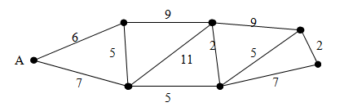

**DOES A HAMILTON PATH AND/OR CIRCUIT EXIST IN GENERAL?**

1. **For each of the following graphs:** Use any vertex to START and/or END
2. **Find a Hamilton Path. If it does not exist, then give a brief explanation.**
3. **Find a Hamilton Circuit. If it does not exist, then give a brief explanation.**

**Graph 1 Graph 2**

