AMDM Name: __________________________
Unit 7 SAS 7C9 Date: _____________ Period: ______

Two sections that share a common edge cannot be colored the same.

1. 2.
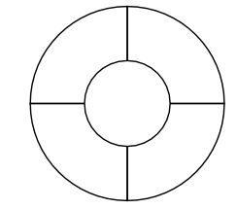

3. 4.
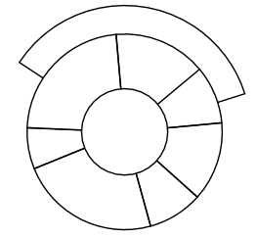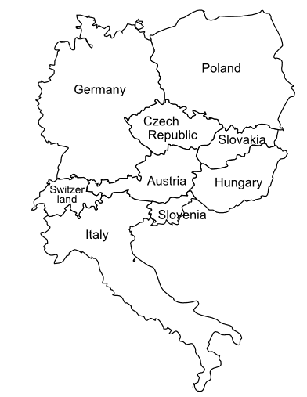

5.
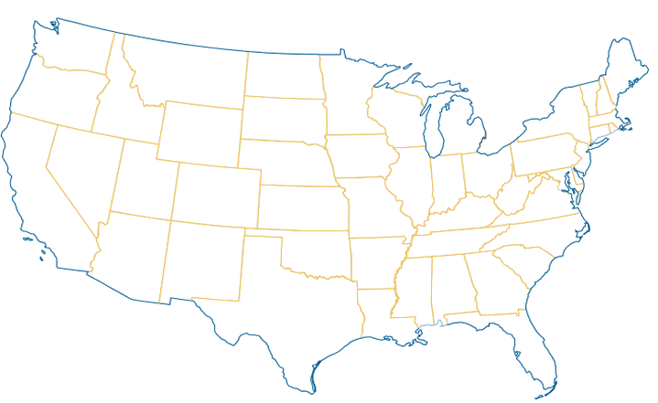

BONUS: Martin Gardner (1975) played an April Fool's joke by (incorrectly) claiming that the map of 110 regions illustrated below requires five colors and constitutes a counterexample to the four-color theorem. Can you refute his claim?
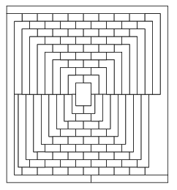
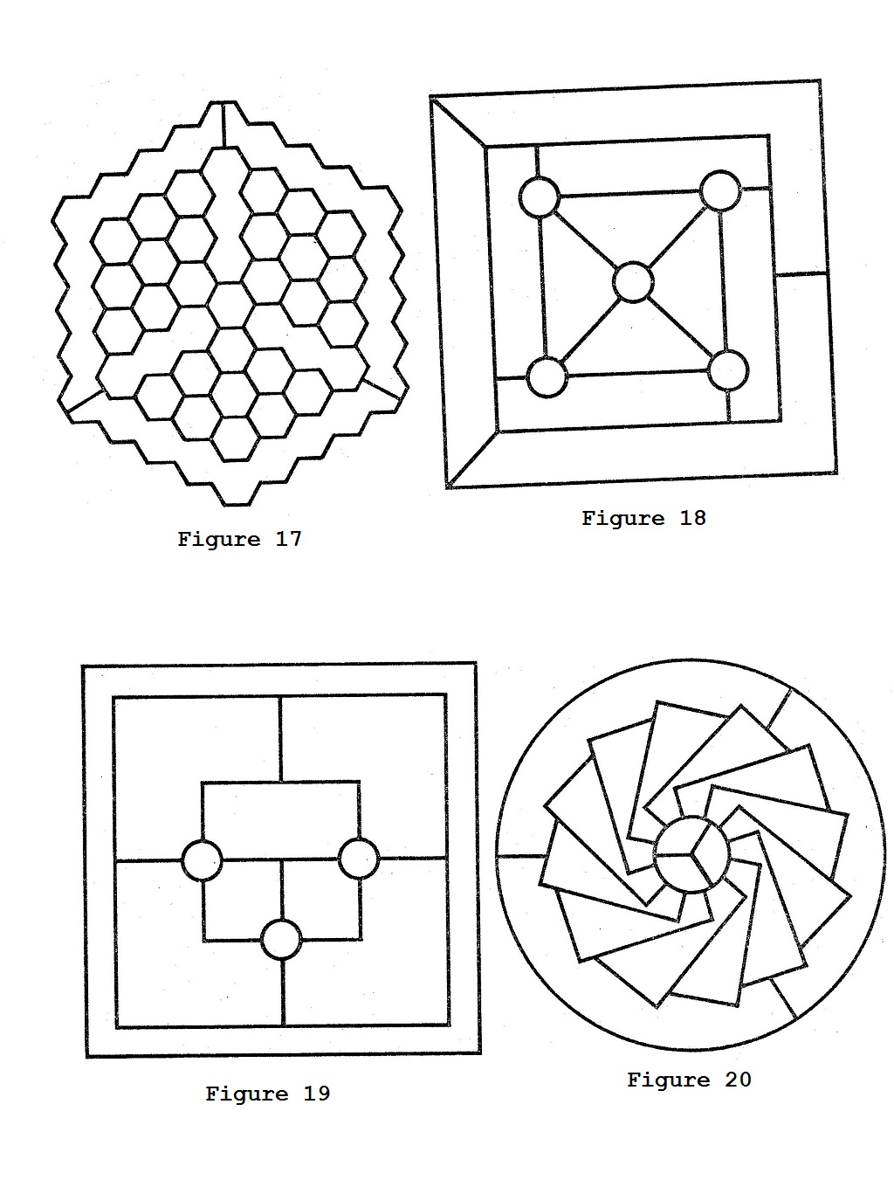
Extension:

