Name: ___________________________ Date: __________ Period: ________
Using Recursion in Models and Decision Making: Relationships in Data
IV.A Student Activity Sheet 1: Using Scatterplots in Reports Day 01

1. Consider the following graph. Who are the subjects in the study? What are the variables of interest? Thoroughly describe the information illustrated by the graph, choosing at least two data points to help with your explanation.
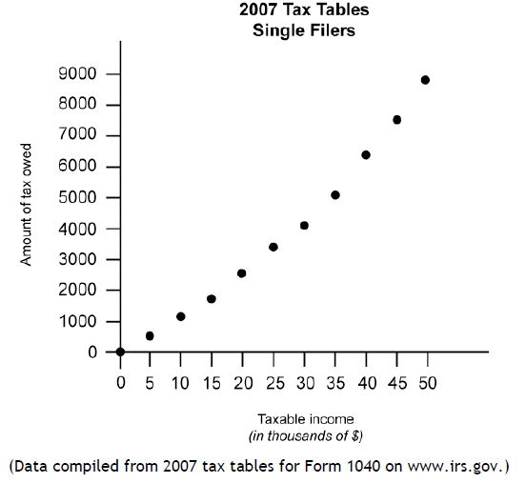

Subjects in the Study: _______________________

Variables of Interest:

1)

2)

Choose at least 2 data points:

Explain what the data points mean in words:

2. Look at this new graph and discuss with your partner the information illustrated. Then compare and contrast this display with the graph in Question 1.
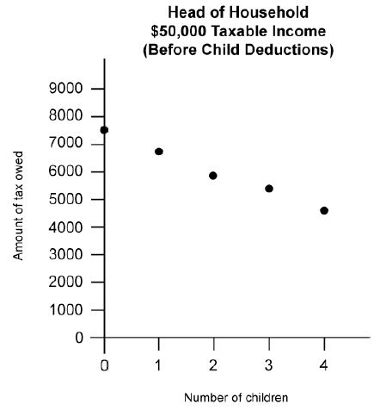

a) How does the shape of this graph differ from the graph in number 1?

b) What is the y- intercept?

c) Explain in words what the y – intercept represents.

d) How much does a head – of – household filer with $50,000 taxable income and no children pay in taxes?

3. REFLECTION: Use the previous graphs to complete the following sentences.

A person with higher taxable income pays _____________________________________.

A person with lower taxable income pays _____________________________________.

This is an example of a ___________________________________________ association.

A person with fewer children pays ___________________________________________.

A person with more children pays ___________________________________________.

This is an example of a ___________________________________________ association.

4. In actuality, head-of-household filers with $50,000 in taxable income and the same number of children could pay different amounts of income tax, as shown by the graph on the right. These differences result from tax credits for expenses such as child care that can reduce the amount of tax owed. Compare and contrast this new graph with the original on the left.
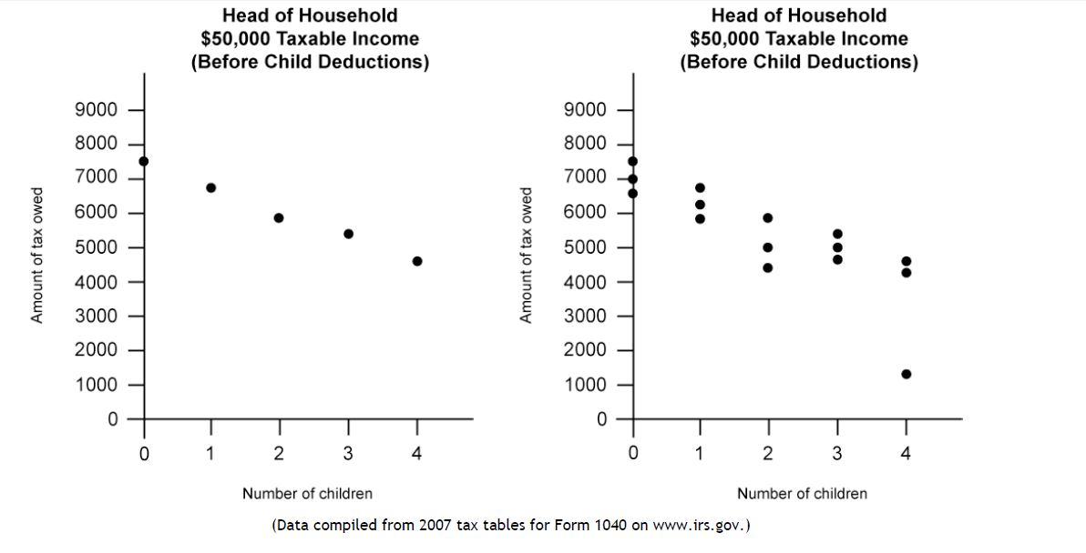

a) Do the graphs show a positive correlation, negative correlation, or no correlation?

b) What is the shape of the graphs (hint: linear, exponential, quadratic, etc.)?

c) Which graph is more variable? Explain how you know.

d) Are the graphs continuous or discrete?

5. Now consider the following graph. What information is displayed? Compare and contrast this graph with the others you have analyzed.

a) What does the graph illustrate?

b) Describe the shape of this graph. What type of function does it represent?

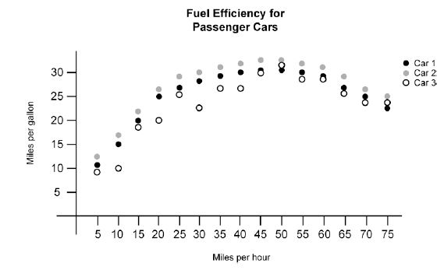
c) As cars go faster, does the fuel efficiency seem to improve?

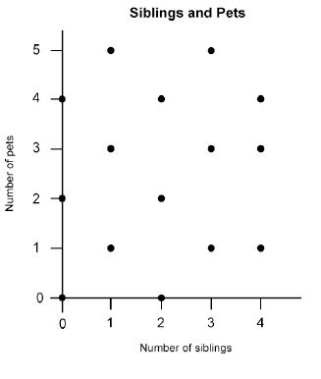
6. A survey of students asked, “How many siblings live in your house with you?” and “How many pets does your family have?” The results are displayed below. Comment on the graph, comparing and contrasting it with the previous graphs.

a) What type of pattern does this graph show?

b) What type of correlation does it represent?

c) Can you infer that students with more siblings have more pets? Why or why not?

